SRILA PRABHUPADA:
THE TRANSCENDENTAL ART MASTER

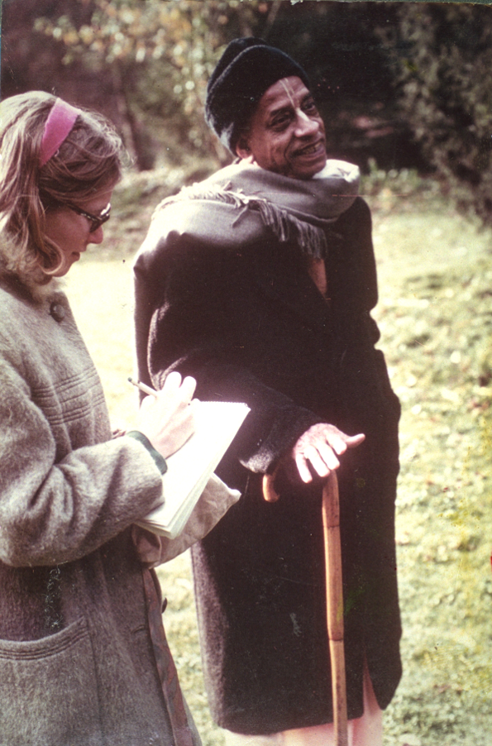

At our very first meeting, Swamiji, who later became known as His Divine Grace A. C. Bhaktivedanta Swami Prabhupada, told us to paint pictures of Lord Krishna. It was in January of 1967. Only a month prior to this, both Gary and I had been art students at the University of Texas in Austin. As soon as Swamiji heard we were studying art, he engaged us in doing transcendental artwork. And he became our “transcendental art master.”
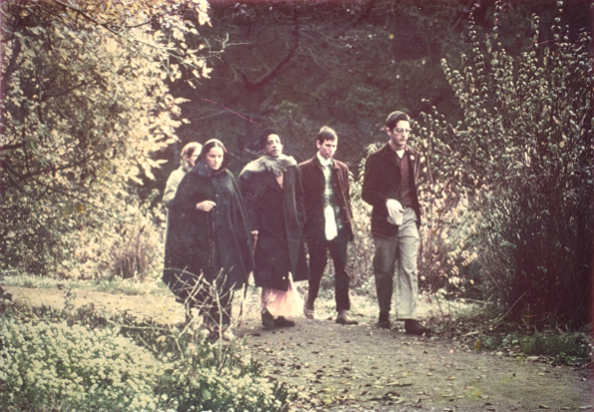
When we met Swamiji, as he was called then, we had been away from the University for little more than a month. So we were never really “hippies.” Almost immediately, we were initiated by him and given the names, Goursundar das and Govinda dasi.
During my first year of college, I had studied under Thomas Payne, one of the best watercolor artists in America. I had also excelled in life drawing, as I had a flair for drawing the human figure. Between my second and third year of college, I studied art in Europe, in France and Italy, and for a short time in Holland. So I was familiar with the Medieval and Renaissance Schools of art, as well as those of the Dutch Masters, and the art history of Europe, as well as England and America. Yet nothing could have prepared me for the wonderful world of transcendental art that Swamiji, Srila Prabhupada, was about to bring to the realm of mankind.
My first assignment was a huge painting of Radha and Krishna, beside a Surabhi cow, near a desire tree in the Vrindaban background. The painting was four foot by four foot; Swamiji gave me a small book jacket to copy. It was the cover of his Srimad Bhagavatam that he had brought from India. Then he described the details.
So only days after meeting His Divine Grace, I was painting daily on this large work, while my husband, Goursundar dasa, read aloud to me the first three volumes of Swamiji’s Srimad Bhagavatam. These three volumes that had traveled with Swamiji from India were the only books we had. Though they sounded like “Indian English,” in places, they were wonderfully inspiring; one of my best memories in life is painting and hearing from those early volumes of Srimad Bhagavatam.
However, since I was a new devotee, I often had to ask questions about the work. Swamiji welcomed my questions; he clearly wanted me to paint everything exactly as he described. So I would go to his nearby apartment, where Hayagriva was often present as well, working with Swamiji on the manuscripts of his books. Hayagriva would ask questions about the manuscripts, and I would ask questions about the artwork. Swamiji welcomed our questions; in fact, he encouraged them.
Since the book cover he had given me was quite small, I had to ask him about various details. For example, I had no idea what color to paint Krishna’s eyes. So, on one occasion, I went to Swamiji’s apartment to ask about this. He was sitting in his rocking chair in the tiny living room, chanting on his japa beads. He welcomed me with a big sunshine smile.
After offering my obeisances, I asked, “Swamiji, what color are Krishna’s eyes?”
For a few long moments, Swamiji was quiet. Then, with a faraway look, as if he were actually gazing at Lord Krishna across the room, he said, with absolute certainty, “Blackish!”
I had the distinct feeling that he simply looked into another dimension, one that I could not see, and into Lord Krishna’s lotus eyes. This was one of the first of many mystical experiences while working with Srila Prabhupada.
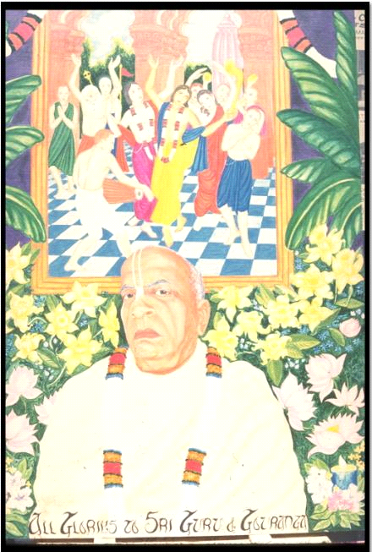
As soon as the large painting of Radha Krishna was complete, and hanging on the Frederick Street temple wall, Swamiji called me to his apartment. There, he gave me several snapshots of himself that had been taken by Mukunda. He told me to choose one of them, and to paint a portrait of him, sitting on the Vyasasana in the newly formed San Francisco temple. He specified that the painting of Lord Chaitanya’s Sankirtan Party should be hanging on the wall behind him, and that “Lord Chaitanya’s Lotus Foot should be just touching the top of my head.”
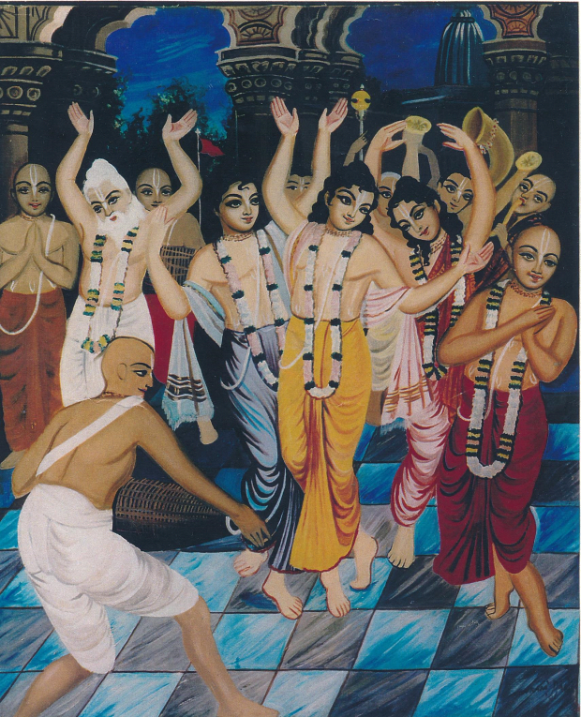

This large painting, four foot by three foot, was to be positioned on the Vyasasana whenever he went away to preach in other places. It was to be treated as if Srila Prabhupada, the Acharya, were present there in the painting.
Admittedly, this painting was much more difficult for me. Though I had excelled in life drawing from models, and faces and figures were my speciality, painting Srila Prabhupada’s expressions proved to be quite a challenging assignment.
Nevertheless, within a month, the painting was successfully completed and hung above his Vyasasana. He seemed pleased with it. It was by then around March of 1967, and Swamiji was planning his return to New York. Goursundar and I traveled with him; he flew and we went by car, crossing the nation in only four days and nights. When we arrived, he had been in New York for only two days.
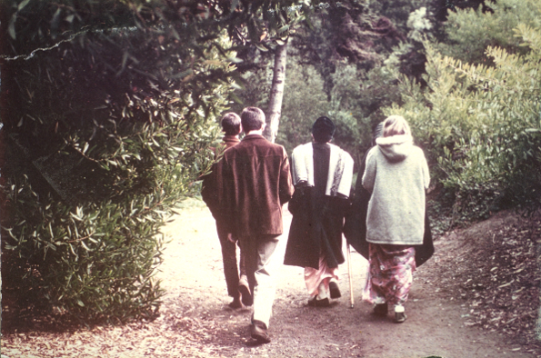
There, Swamiji introduced us to the small New York group of devotees, as “his artists from San Francisco temple.” We were immediately welcomed as part of the New York devotee family, sharing prasadam with such wonderful devotees as Brahmananda, Gargamuni, Rupanuga, Rayarama, Achyutananda, Satsvarupa, Jadurany and others.
We were given work space in “Swamiji’s art studio”, which consisted of the tiny living room in his upstairs apartment. There, just after Swamiji’s morning class breakfast prasad, we spent our days. At night, after his evening class, we slept on the floor of the 26 Second Avenue temple. We later stayed at Satsvarupa and Rayrama’s apartment, until we found a tiny place of our own.
We often found ourselves in Swamiji’s apartment late into the evening, clustered around him like a family, listening to his wonderful talks about Krishna. We were truly just like a transcendental family, and he was our beloved spiritual father. There was only an atmosphere of spiritual love. There was, at this time, no money, no power, no politics, so no positions to defend, and no conflict amongst us. It was a special time when Swamiji was the center of our world, and we all joyfully served him as brothers and sisters.
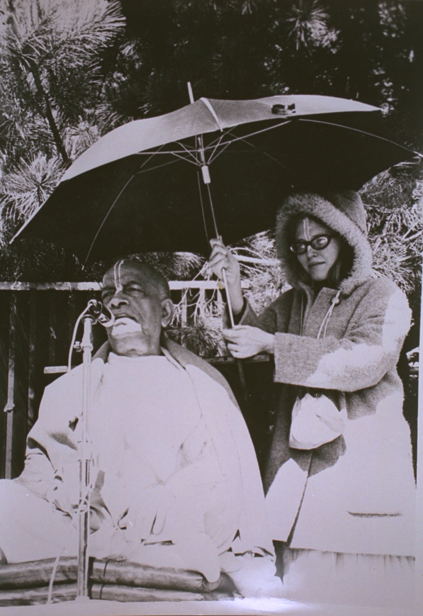

Throughout the day, Swamiji would walk in and out of his tiny living room cum art studio. His small apartment had a tiny kitchen, a bathroom, and two rooms, with a window between them. Swamiji would work and sleep in one room, and the other room, the living room, was the art studio. There, Jadurany sat painting in one corner. Goursundar and I sat on the floor painting in another corner. The atmosphere was delightful and intimate, as Swamiji would watch our work and often give encouragement and guidance. He seemed to enjoy walking in and out of the art studio, many times a day, looking at our work, and giving directives.
Our first assignment in New York was to paint a whole series of pictures to illustrate the story of Prahlad Maharaj. Swamiji wanted this series to be used as a children’s slide show, in order to educate them about Krishna consciousness. So the drawings were designed with children in mind. Since these paintings were to attract young children, he wanted them to be simple and colorful.
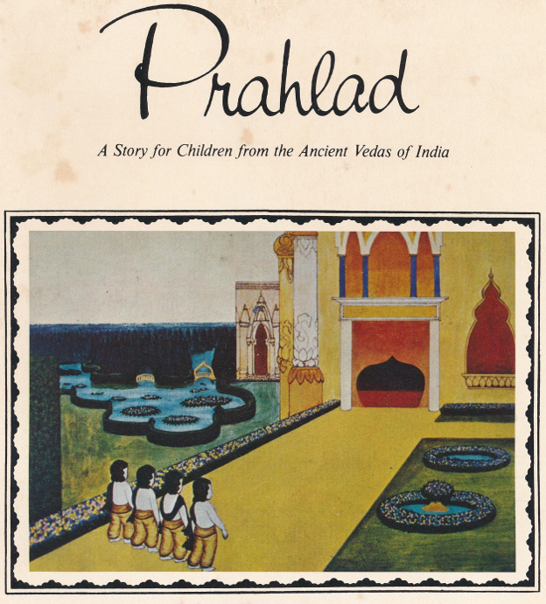
**Indeed, this Prahlad series was later used in slide show presentations in London and other places, and also printed into a soft-bound children’s picture book called “Prahlad.”
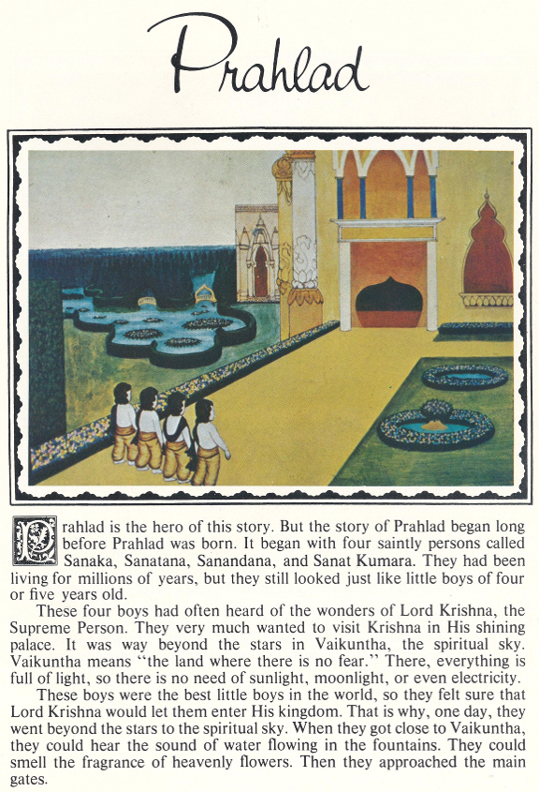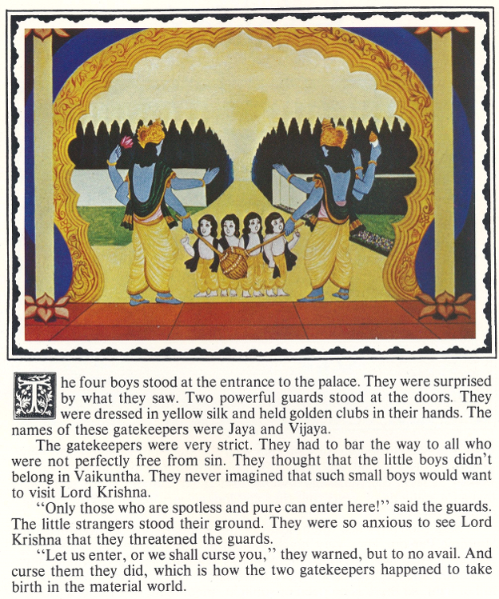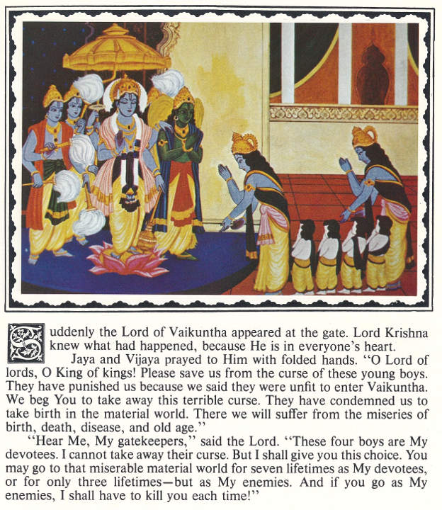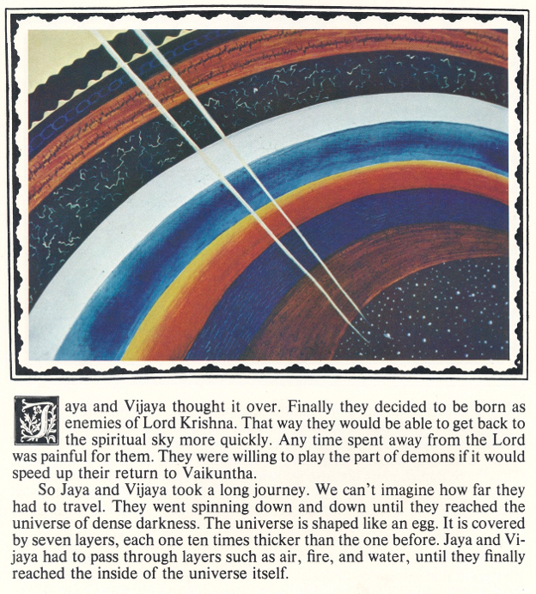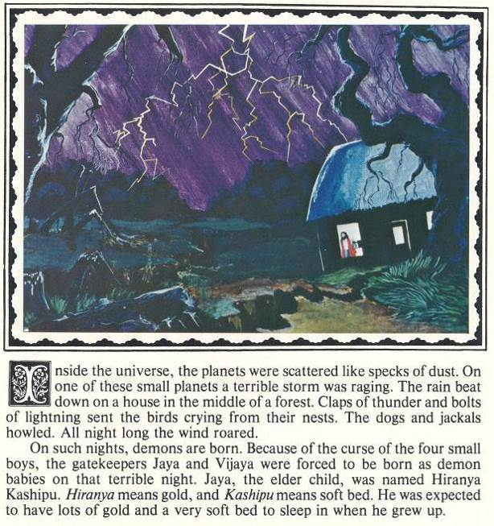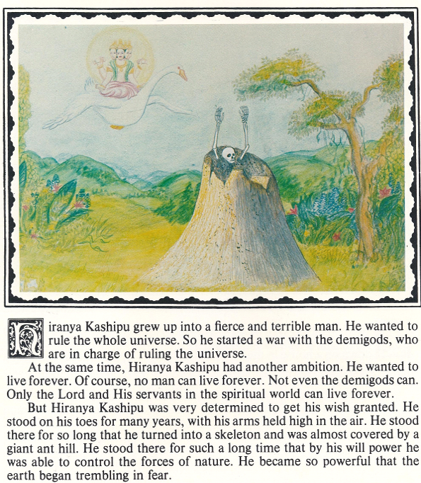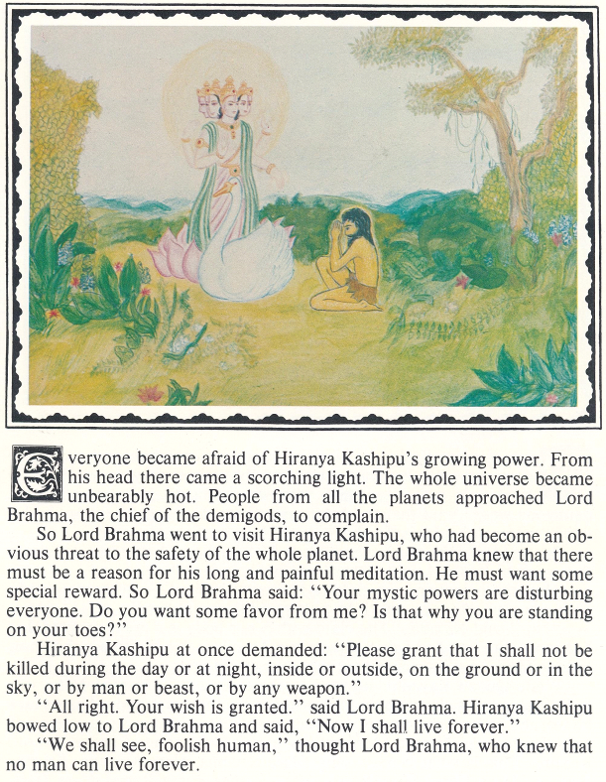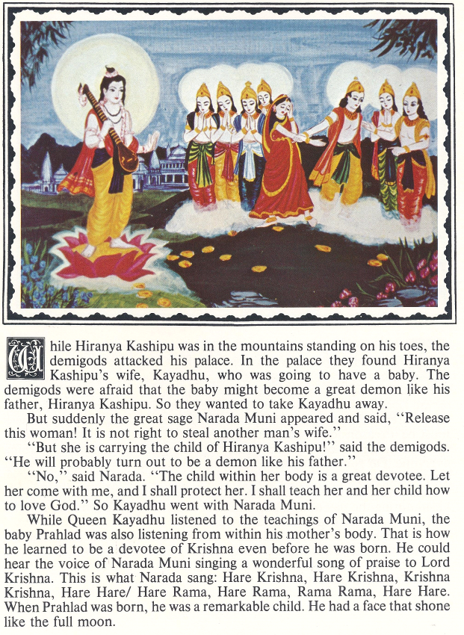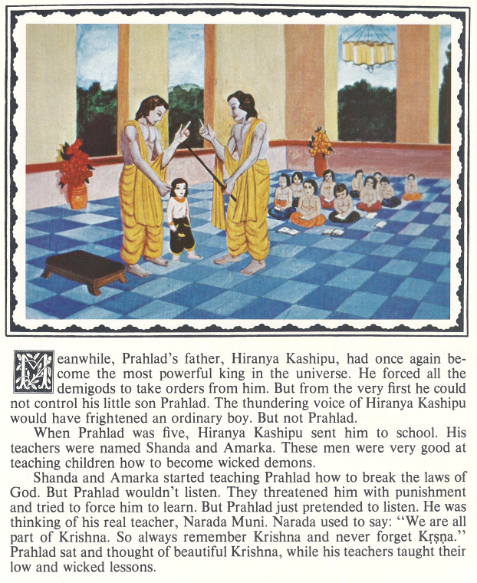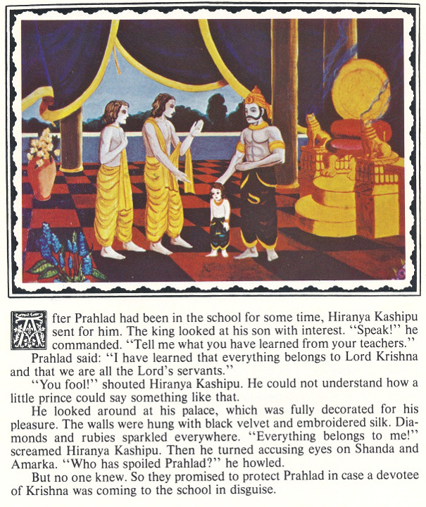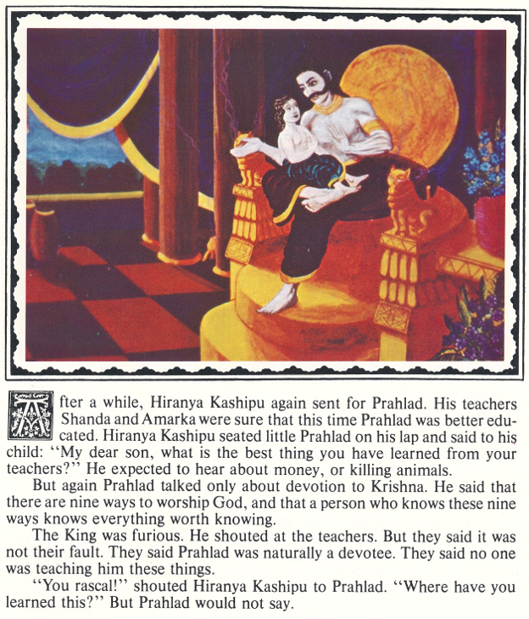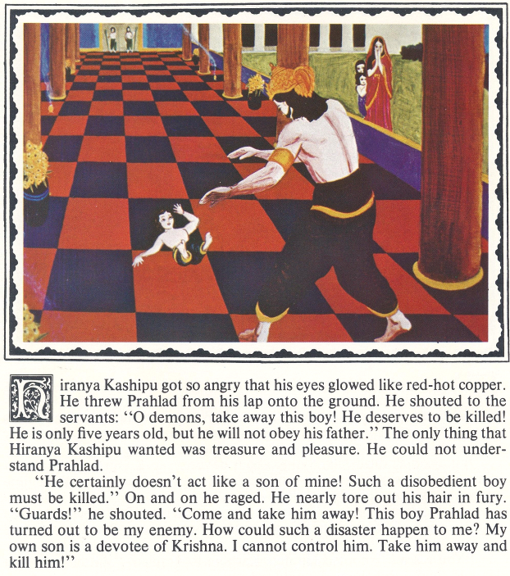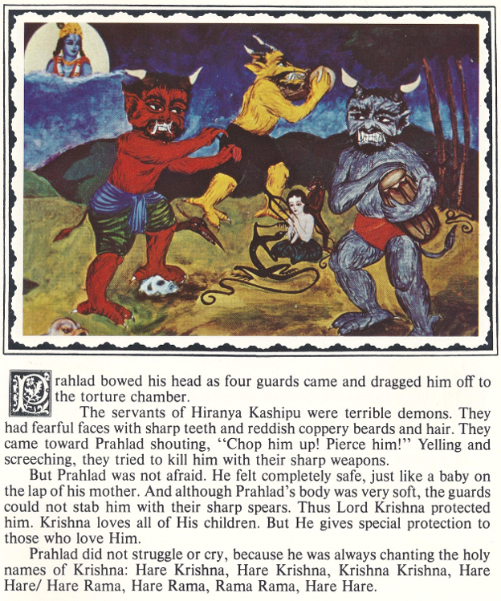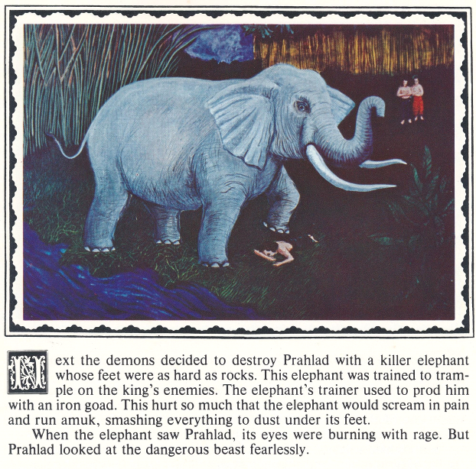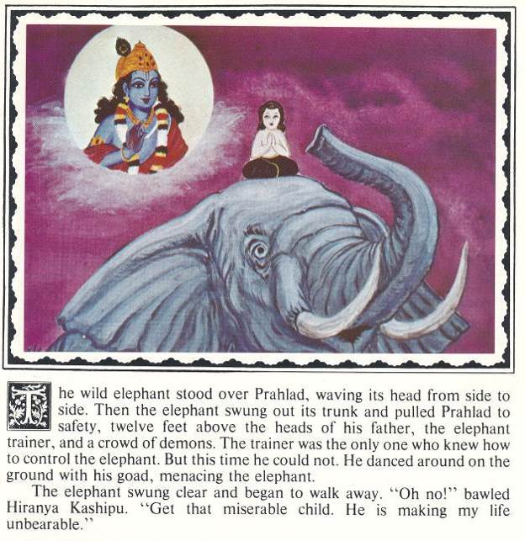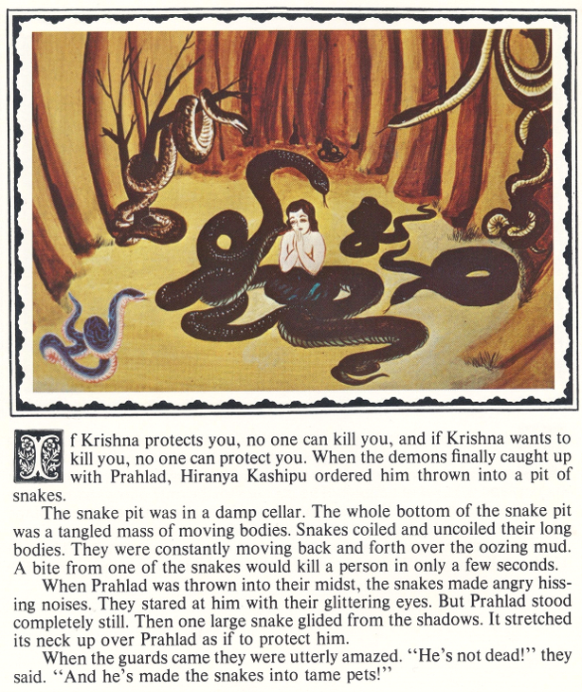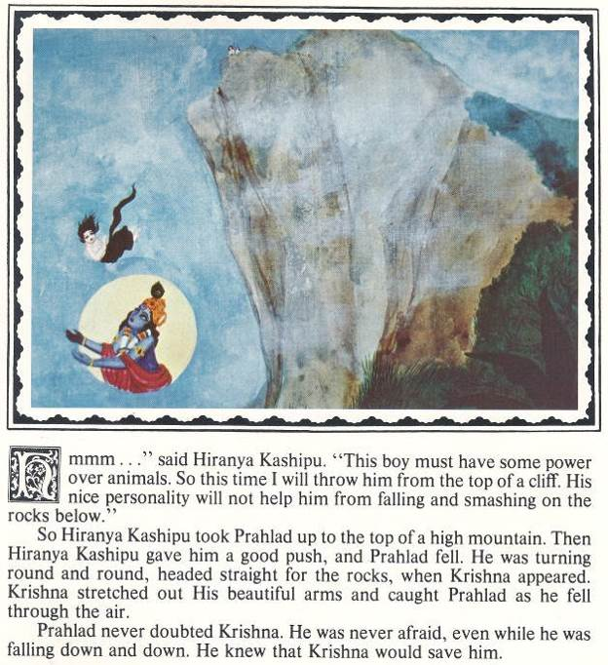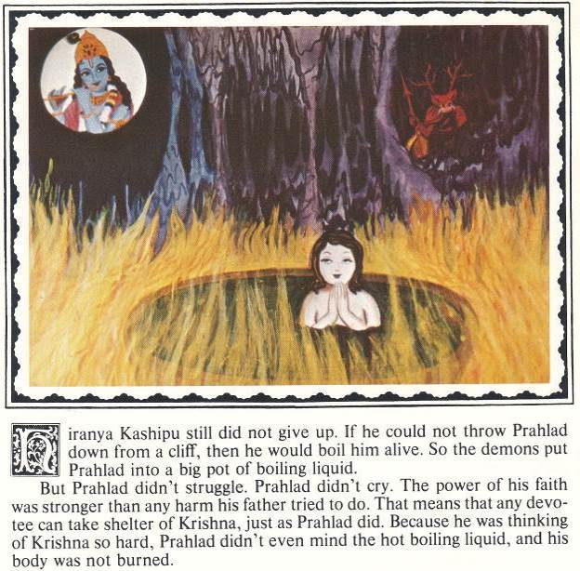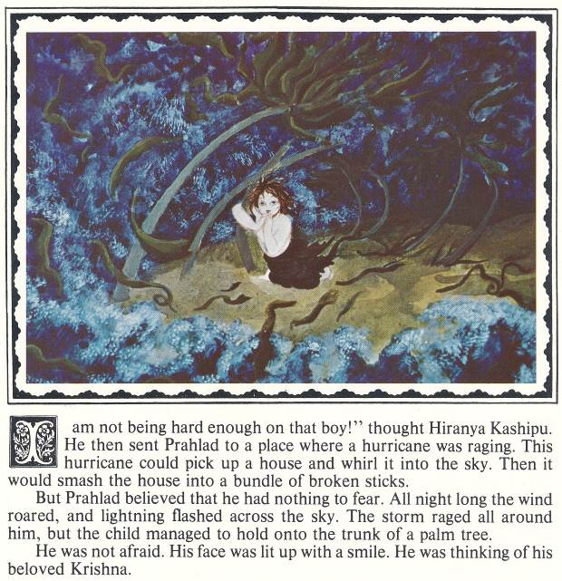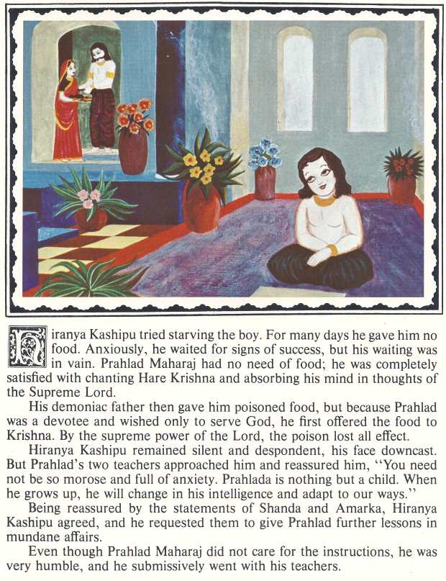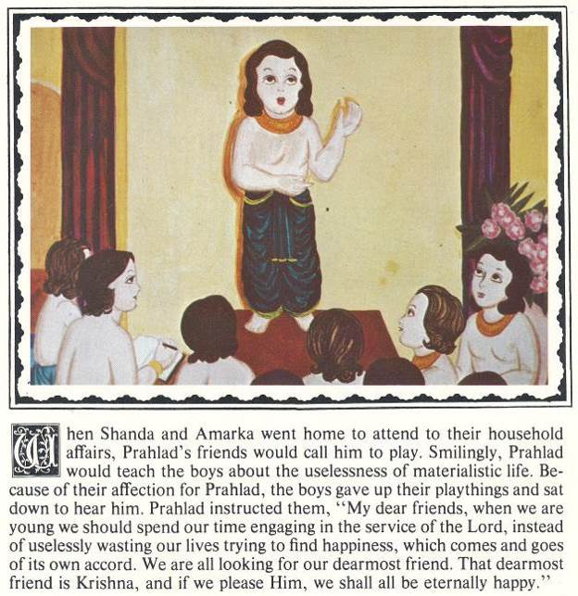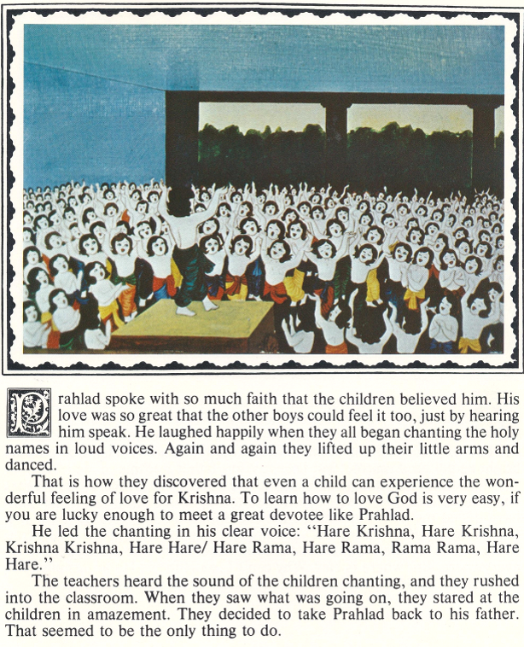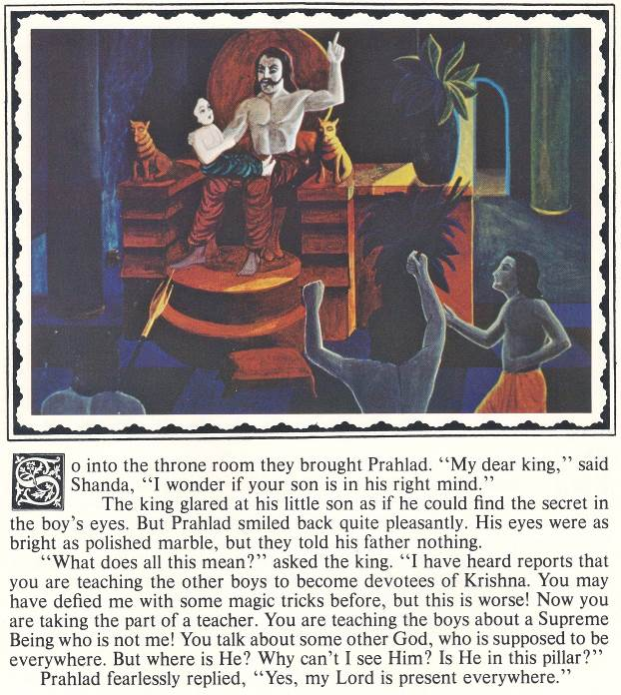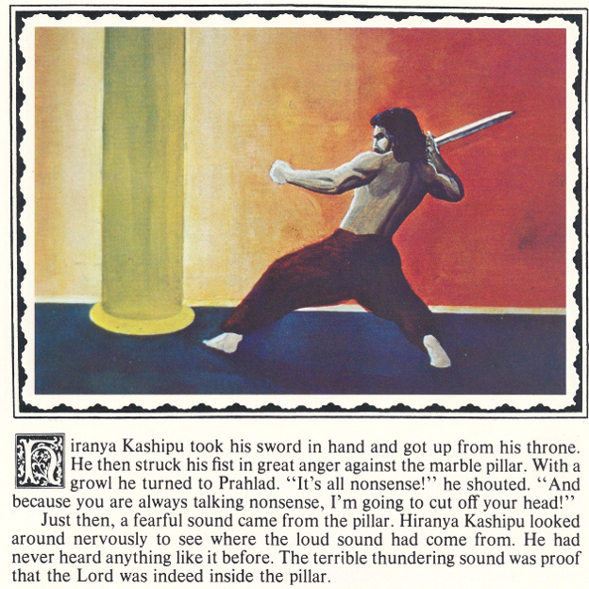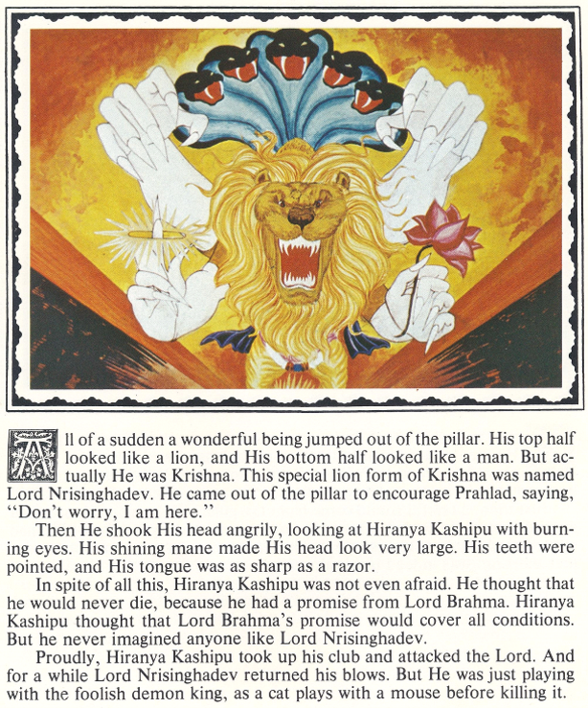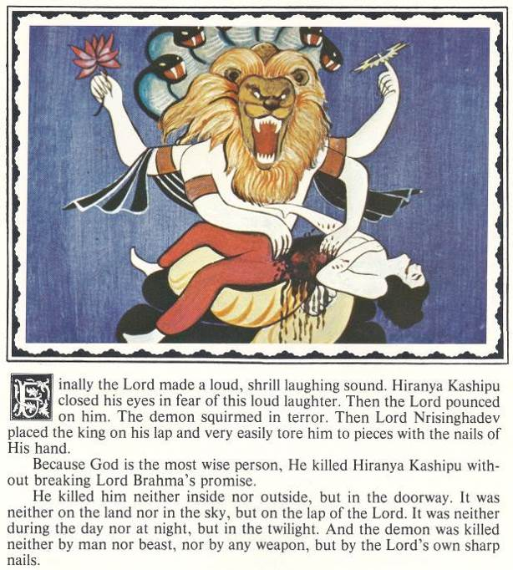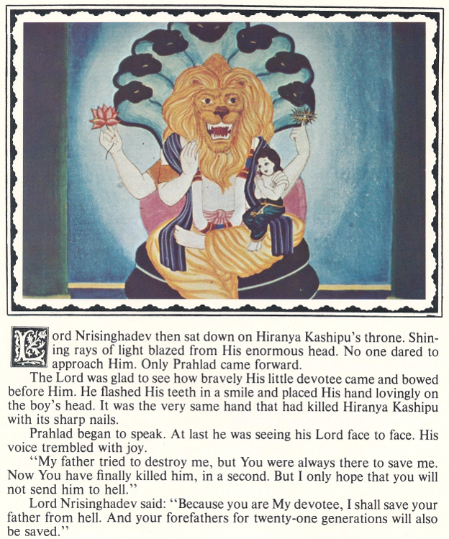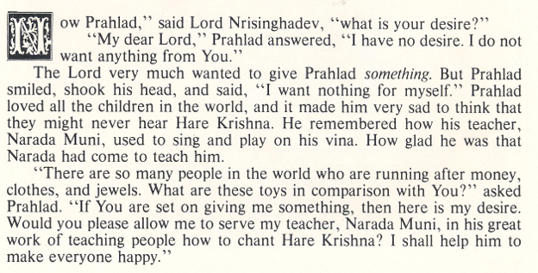
It so happened that at that time, Swamiji was daily translating the part of Srimad Bhagavatam that described the pastimes of Prahlad Maharaj and Lord Nrsinghadev. So he was constantly absorbed in the mood of Nrsingha Lila.

Since that canto was not yet available, we did not even know the story of Prahlad Maharaj! However, he was speaking daily in his morning class on this pastime, and he gave us more and more description as we worked. Swamiji guided us every step of the way.

In fact, Swamiji often posed for us to help describe the events in the story! On one occasion, he posed for the demon Hiranyakasipu, standing on his tippy toes with his arms held high, in the middle of our little art studio--but only for a minute. This was to illustrate Hiranyakasipu’s yogic penance. On another occasion, he wrapped himself in a long white cloth, like a dhoti, and posed as Krishna, in a “three-fold bending posture.” This was so that Jadurany and I could see Krishna's special posture, and sketch the way the folds fell in the type of dhoti Krishna wears. There were many such instances.

Surprisingly, on numerous occasions, (nearly every day) Swamiji would pose for Lord Nrisinghadev! He seemed to love to demonstrate Lord Nrisinghadev’s leap from the pillar! In fact, he seemed to delight in doing this! He would raise his hands like claws, his eyes would get big and show the white on top, and he would roar like a lion--showing us how Lord Nrsinghadev should look while attacking Hiranyakasipu! He would perform this pastime daily--often more than once. I later realized that he was simply absorbed in Nrisingha Lila, translating Srimad Bhagavatam each morning, and speaking about Prahlad Maharaj in class every day. This was indeed his lila absorption at that time, and it was spiritually delightful, as well as instructive.

On one occasion, Swamiji told me to paint Prahlad being tortured by demons. He said they should have horns and pitchforks and knives and look very mean and ugly. Truly, I had no idea what such demons should look like! So I researched ugly monsters in comic books. Then I made composites of them, giving them ugly faces, long claws, horns, and pitchforks. I then presented the sketches to Swamiji.
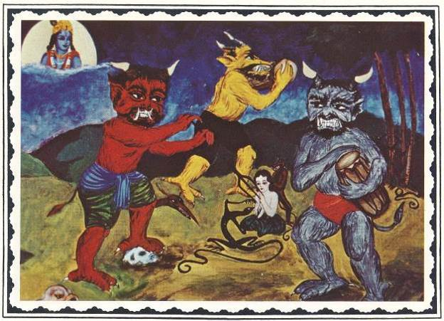
He studied the sketches carefully, then said, “Yes, this is good. These are good demons. Even now, there are many such demons in dark jungles of Africa and other places, even in the snowy places like the Himalayas.”

Swamiji said this in such a matter-of-fact manner, and with such certainty, that I was taken aback. After all, I had never heard of such things in my so-called well-rounded college education! Horned demons with pitchforks?

Surprised, I gasped, “Oh! I didn’t know that!”

Calmly, almost dead-pan, Swamiji looked at me with serious compassion and said, “There are many things you do not know.”

He said this with such wisdom and compassion, that for a moment, I realized I was standing at the threshold of real knowledge, and that all true knowledge would be coming from him.

Those early days in “Swamiji’s art studio” were surely some of the best days of my life. I can look back and they still seem more real and alive than many of the other events that have been a part of my life later on.

Those wonderful art studio days lasted from March to May, and then tragedy struck. Swamiji had a stroke, a near fatal stroke. It had to be the worst day of our lives. Jadurany and I hung by the window that separated his bedroom/workroom from the living room art studio. Tears streamed down our cheeks as we watched Brahmananda and Satsvarupa sit Swamiji up, and open his Bhagavatam at his request. Trembling and breathless, Swamiji read from the Srimad Bhagavatam. Even if it were his time of death, he was determined to give every breath for glorification of Lord Krishna! And he was determined to teach us everything he could, in whatever short time he had. I witnessed his incredible compassion and loving concern for us, his spiritual children.

Swamiji instructed us to pray to Lord Nrisinghadev for protection and to ask that he be allowed to remain with us in this world. He had so much more to teach us! Even when he went to the hospital, we continued to chant the Nrisinghdev prayers; we were praying fervently for his recovery.

We took turns going to the hospital to see him, to bring him foods, to massage his lotus feet, and to shower our love and express our desire for his speedy recovery. It was an intense time. We all loved him so much that he was in the center of our minds, our hearts, and our conversation day and night. In such a short time, he had become like our beloved father. We all felt we could not live without him.

After only a week or so, Swamiji left the hospital. Rayarama and Brahmananda arranged a house for him at the New Jersey seashore. Goursundar and I were selected to go there and stay with him, and care for him, along with Kirtanananda. Ostensibly, it was because we were artists, the only married couple, and we could be spared from the busy schedule of work and temple duties. Several of the devotees had day jobs, and others were needed for cooking and maintaining the temple programs. But I knew there was a deeper reason.

That fateful night of Swamiji’s stroke, with my face pressed against the window weeping, I had some deep realizations. As if guided by Lord Krishna within my heart, I understood that he would not be with us long, and that what he was doing was the most important thing in the universe. So I made a vow. It was a secret vow; I told no one of this, not even my husband. But Lord Krishna in my heart witnessed my vow.

I vowed that as long as he was here in this world, I would do whatever I could to help him, to make him comfortable, and to make his mission the absolute center of my life. Whatever that meant--scrubbing floors, cleaning his refrigerator, preparing his medicines, cooking, cleaning, typing letters, transcribing his books, or painting pictures for him. It was a simple vow of absolute love and surrender, with nothing held back. And it was coming from the heart of a simple young girl. But it was sincere, straight from the heart. I was determined to make his life as easy as possible so that he could do his all important work for Lord Krishna, and for humanity.
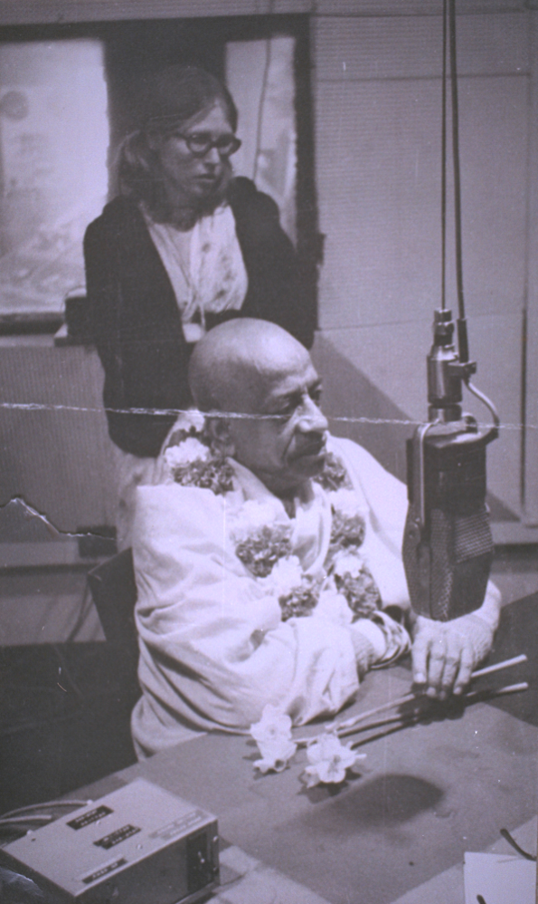I still believe it was for this reason that I was taken by Rayarama to the New Jersey seashore, to the beach rental, in order to clean it thoroughly and prepare it for Swamiji’s arrival. That became my focus, my service, and my life. I was dedicated to making him comfortable and well cared for.

So when Swamiji arrived, the apartment was spotless, and fragrant with many vases of fresh picked roses. Daily, I picked bagfuls of sweet smelling roses, and he often said, “Flowers are Krishna’s smiling!” Swamiji would hold a rose in his hand, and breathe in its fragrance, and say it took away his headaches. He was especially fond of yellow roses, and would often say, “I think this yellow rose is the most fragrant!”

During those three wonderful weeks in Long Branch, New Jersey, I did only one small painting. It was of Lord Chaitanya traveling with Lord Nityananda. It was a copy of a picture from India. At first, Swamiji encouraged us to copy Brijbasi prints and other Indian works, while he gradually guided us into this new style of art. This was much like my art teachers in college had done. Until we developed a style to his liking, he wanted us to study the devotional artwork of India. He was not so favorably inclined toward the artwork of Europe.
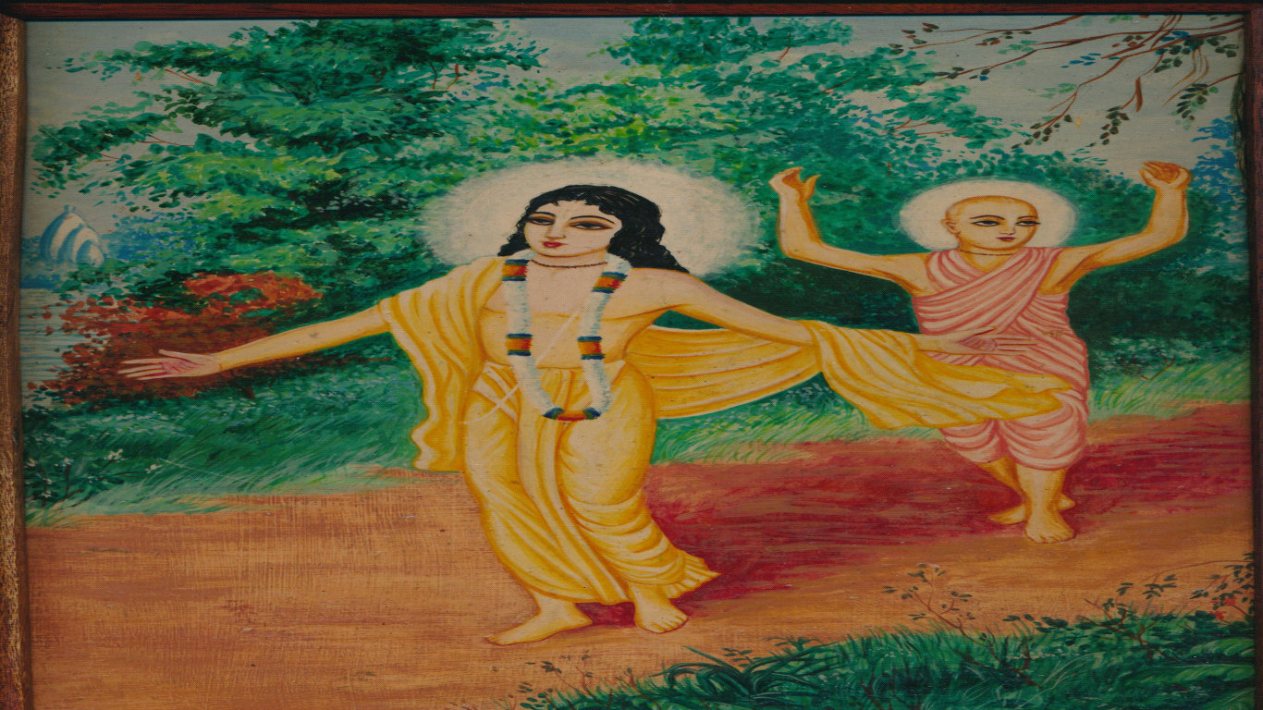
Perhaps because I had also studied the works of the Medieval and Renaissance masters while in Europe, I understood the importance of having devotional mood imbibed into paintings. The religious paintings of old masters in Florence, Venice, Rome, Paris, and elsewhere were often filled with “bhava,” devotional spirit, and I had first hand experience of this. Many of these works evoked spiritual feelings in the minds and hearts of their viewers. The old masters usually had apprentices who did their bidding, laying in backgrounds and blocks of color, but the paintings were usually designed and completed by the masters’ own hands. And the paintings, usually of a religious nature, were a reflection of the masters’ own mood of devotion.

The mood of devotion that Swamiji wanted reflected to the world was indeed his mood of devotion. We were simply apprentices, much as the old masters had apprentices who painted while the masters guided their hands. The old masters would design the compositions, and instruct their apprentices, even in the finest details. But, in the end, they would strive to imbibe their own devotional spirit into the work.

Swamiji went even further than this--because he could. Swamiji actually implanted his devotional mood into those early paintings, via his apprentices! This is why, on later seeing changes to his books, he said, “Why have you removed those early paintings? They were full of bhakti!” They were full of his devotion!

Swamiji guided our hands as well as our hearts. His mystic potencies enabled him to do that. The old masters could guide the hands of their apprentices; Swamiji could guide our hands, our minds, and our hearts so as to get the desired result. We were his apprentices in every way, through and through.

Soon after our brief stay at the Jersey seashore, Swamiji left for India to recover his health. He went to Vrindaban, to “get well or to leave this world.” We anguished with the fear that he would never return, so we prayed constantly that he would quickly get well, and come back to us.

Goursundar and I went to the Montreal temple for the months that Swamiji was away in India. Having been trained by him for several months, we continued to do line drawings for his Back to Godhead magazine. We designed covers, did illustrations, and tried to make the magazine more attractive, though we were limited to black and white due to printing costs.
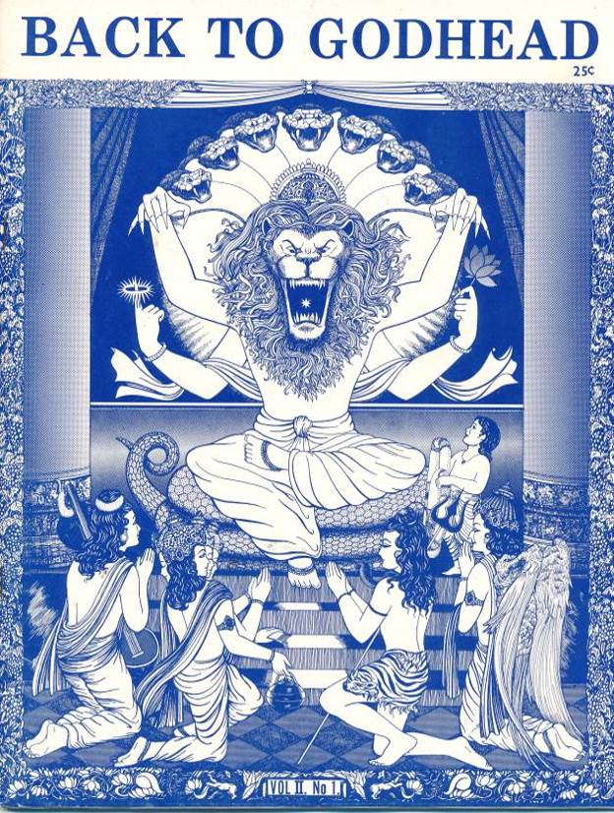
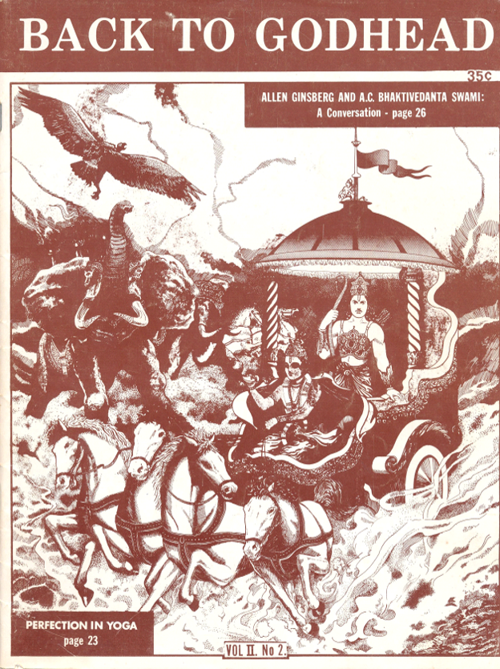
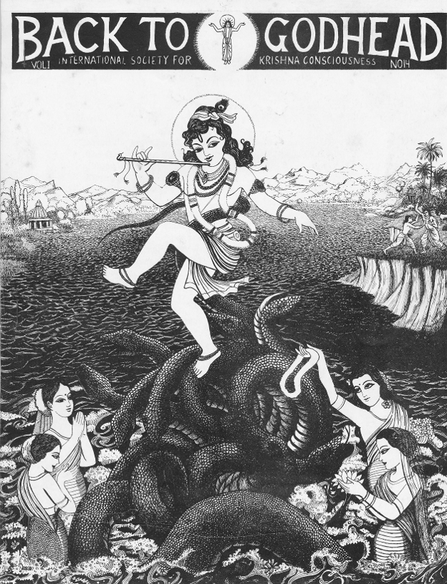
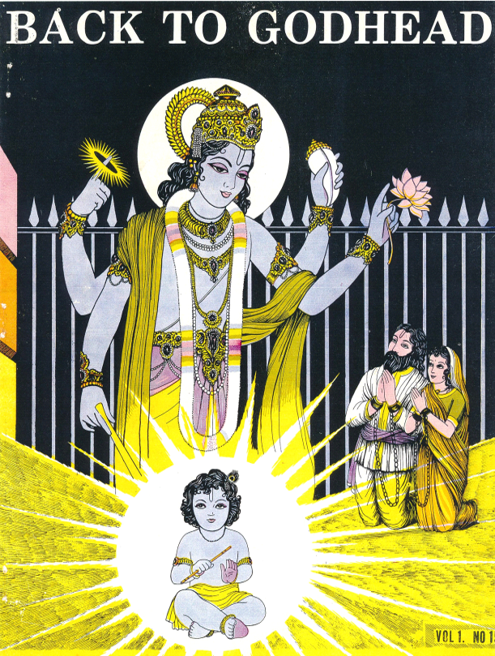
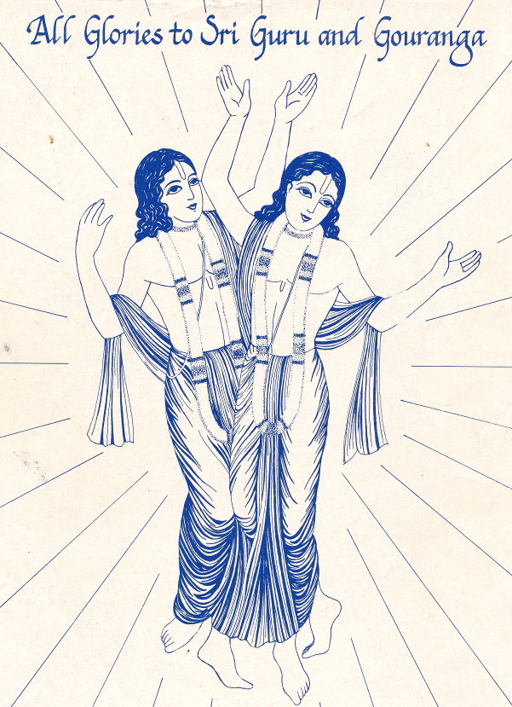
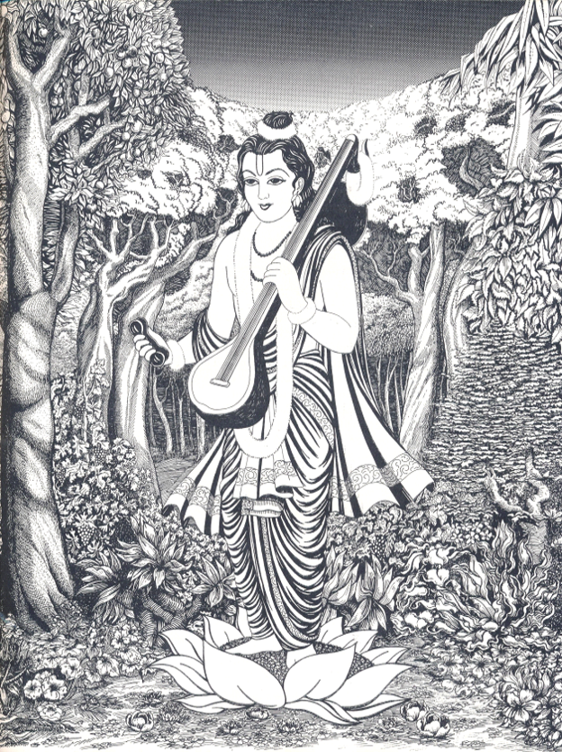
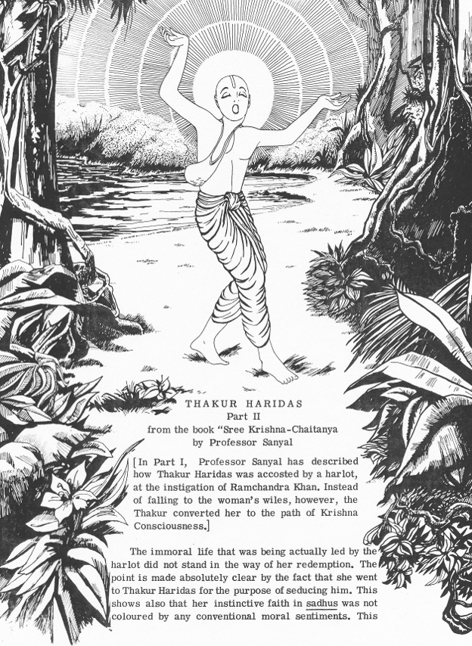
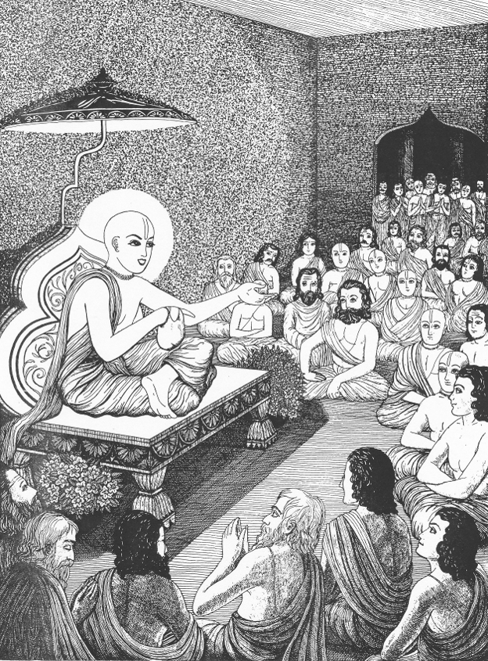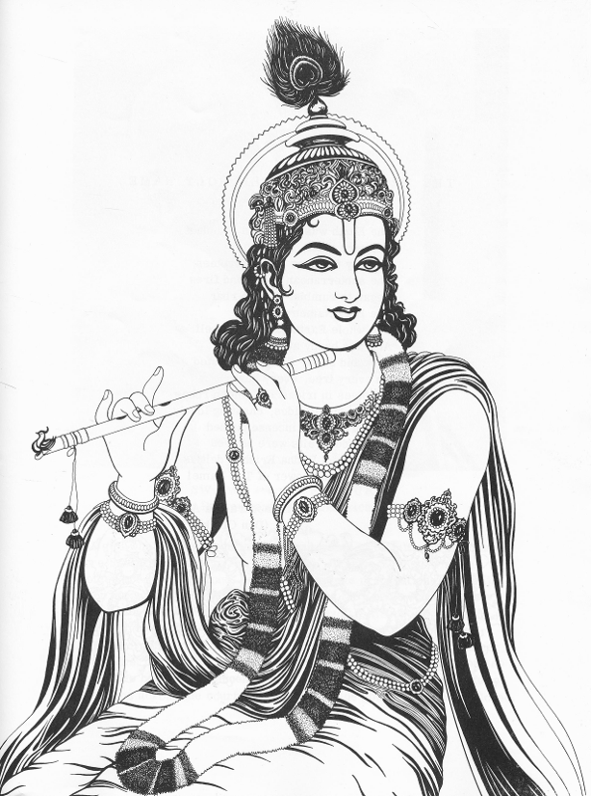
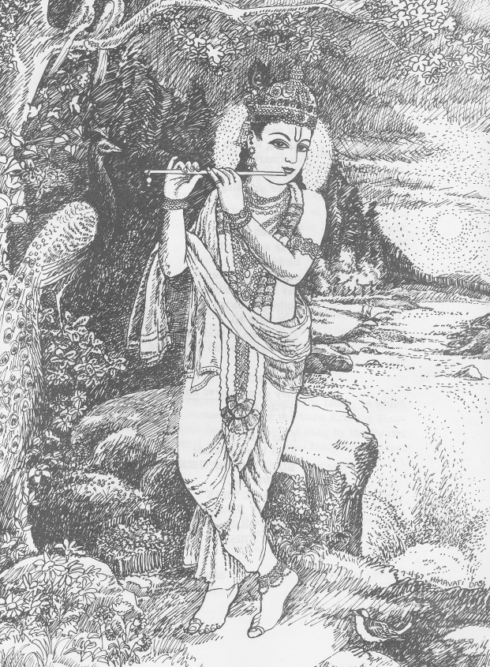
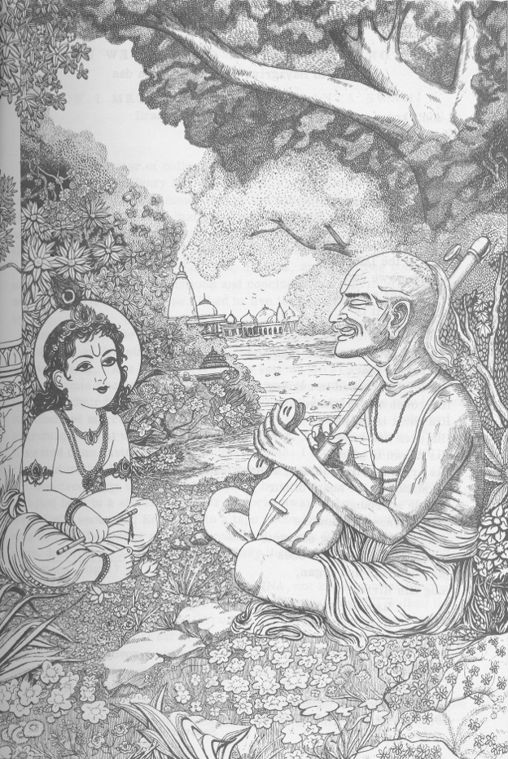

It was at that time, feeling great separation from Swamiji, that I designed a drawing of Krishna returning home from the forest with thousands of cows. It was indeed a special drawing, for though I had never seen Vrindaban, or even photographs of it, just from Swamiji’s many descriptions of Vrindaban, I was able to create a picture that did indeed look very much like Krishna’s Vrindaban.
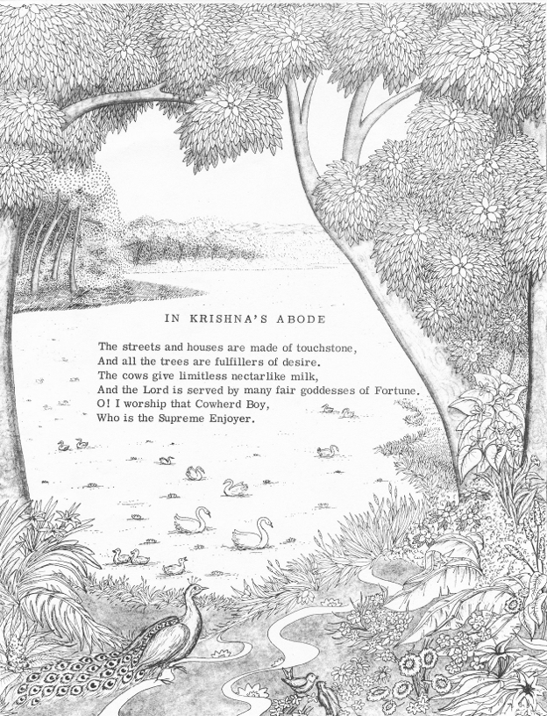
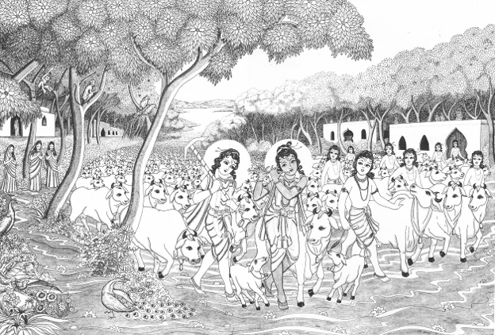

While doing this drawing, I was seeing cows and cowlads in my minds’ eye for weeks! I selected one particular cowlad to be Swamiji, and sent him a copy of the picture, denoting that the cowlad on the far right of Krishna was my depiction of him.

Years later, this early drawing of Krishna’s Vrindaban was artfully colored in by some of the later BBT artists, and is still used today in many of the books and temples. It is a painting that is full of bhava. That is because it is Swamiji’s drawing--not mine. It is full of his devotion. Remember, I had never even seen Vrindaban. But he was able to convey it to me so perfectly that the mood of Vrindaban is indeed present in that picture!

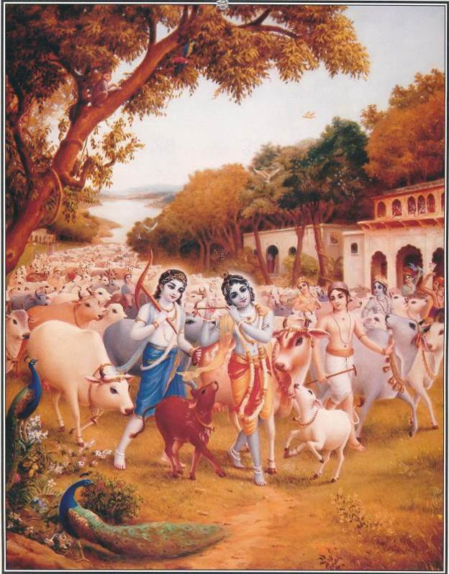

And he was also able to guide me from within my mind and heart just how he wanted it done. This is the deeper, more spiritual, understanding of transcendental art. It doesn’t come from us; as artists, we have to open ourselves so that Srila Prabhupada’s devotion comes through us. This mood requires surrender of the arrogant and rebellious attitude that “I am the doer.” Or “I am the artist.”

Art, like music, can come from the heart, or it can come from the lesser planes of consciousness, such as the mind or false ego. True transcendental art comes from the heart, and is infused with devotion, and that devotion can be felt even by the casual viewer. Srila Prabhupada would often say that our paintings were “windows to the spiritual world.” And he alone amongst us knew what the spiritual world must look like!

Music, especially kirtan, can come from the heart and fill the soul with love of God. Srila Prabhupada’s singing, so full of bhakti, strikes the chords in our heart, and feeds our souls. Such is the power of transcendental music, with the pure soul’s chanting of the Holy Names.

Sometimes, we hear good kirtaniyas singing, but because there is more concern with musical expertise and delivery than with connection to God, the sounds become material and do not have the same effect. We all know instances of this, when the kirtan leader is more self-absorbed, more concerned with the thought of “sounding good,” and is thus more self-conscious than Krishna conscious.

Art is like that too. If the artist is trapped within the mental plane, and is thus more concerned with fame and false ego, than serving God and Guru, then the work loses its transcendental quality. And it fails to touch the heart of the viewer. It becomes material, and though it may have some spiritual subject matter, it does not carry the scent of bhakti.

We have all had ecstatic kirtan experiences when the kirtaniyas leave their ego at the door, allowing the magic of kirtan to spontaneously unfold. And we have all experienced kirtans that did not stir our hearts. Art is like that as well, and transcendental art, following the guidelines laid down by the Acharya, will have the desired effect. It will stir the emotion of the soul.

When an artist thinks, “Oh, I am an artist, this is my creation!” that is one level of consciousness. It may have its place in life, for worldly subject matter, for entertainment, for the fulfillment of personal ambitions, and ego gratification. But this consciousness is not useful in the creation of transcendental art. All this can be understood from the direct teachings of Srila Prabhupada to his artists, his apprentices, especially those who spent much time with him in his little art studio.

Swamiji returned from India on December 14, 1967. Goursundar and I traveled from Montreal to San Francisco, and were there to greet him at the airport. From that day, until January of 1969, over a year later, we were with him every day. Goursundar gave him massages, and worked on the translation of Chaitanya Charitamrita, and I did the cooking, the cleaning, taking dictation, and typing his letters, transcribing his tapes of Nectar of Devotion and Chaitanya Charitamrita, as well as packing his trunk for travel. I simply wanted to assist him and make sure he was comfortable in every way possible. So I did whatever I could think of--even making little hats for him to keep his head warm in the early morning hours while he worked, translating his glorious books in the presence of the Lord.
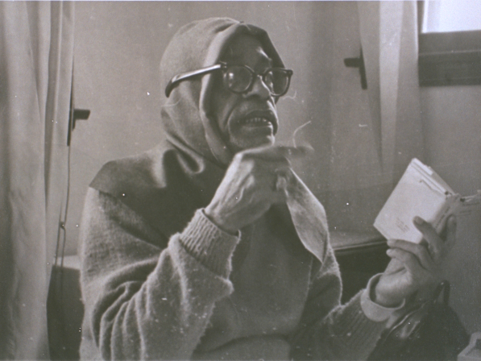

During that year of traveling and serving Swamiji, who came to be known as “Srila Prabhupada” in May of 1968, there was little time for artwork. While with him, however, I did at least do the cover for his Bhagavad Gita As It Is, and the several illustrations for Teachings of Lord Chaitanya. These drawings were directed by him quite specifically. He would often stand behind me and look over my shoulder as I worked.
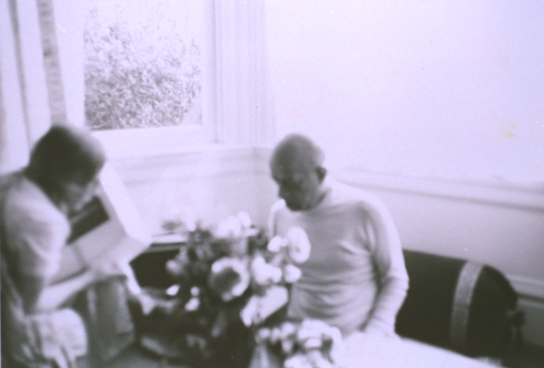

First he would describe how the picture should look, and give an example, sometimes even a sketch, of the composition. I would take notes on his instructions, then I would make drawings and show them to him, and after that, he would make corrections and advise me on improvements, and then at last he would give his final stamp of approval. Then, while I was working, he would often come to see how the picture was developing. This was the common practice.

In this manner, during that same year of 1968, Srila Prabhupada guided me every step of the way in producing the line drawings for Teachings of Lord Chaitanya. He described the compositions, decided which figures would be present and what they would be doing in each drawing, and what backgrounds should be shown.
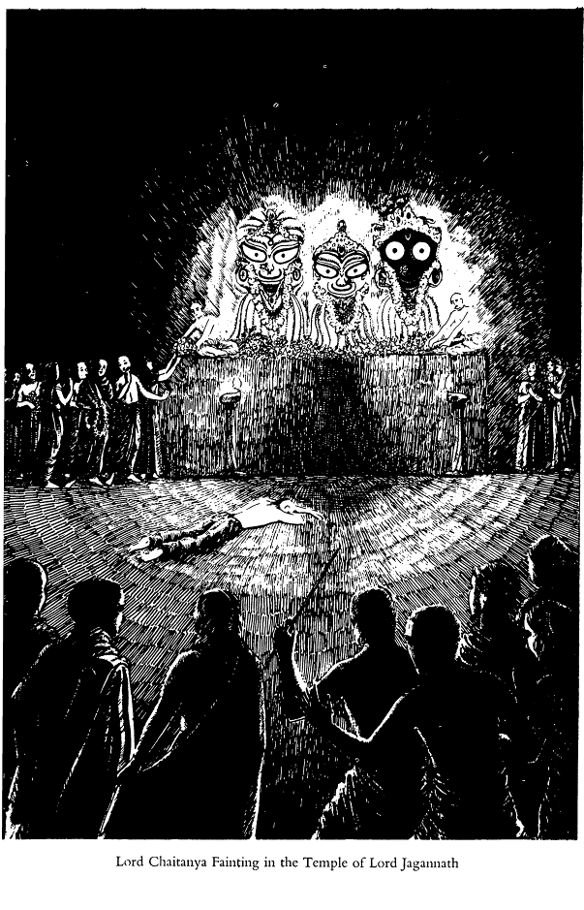
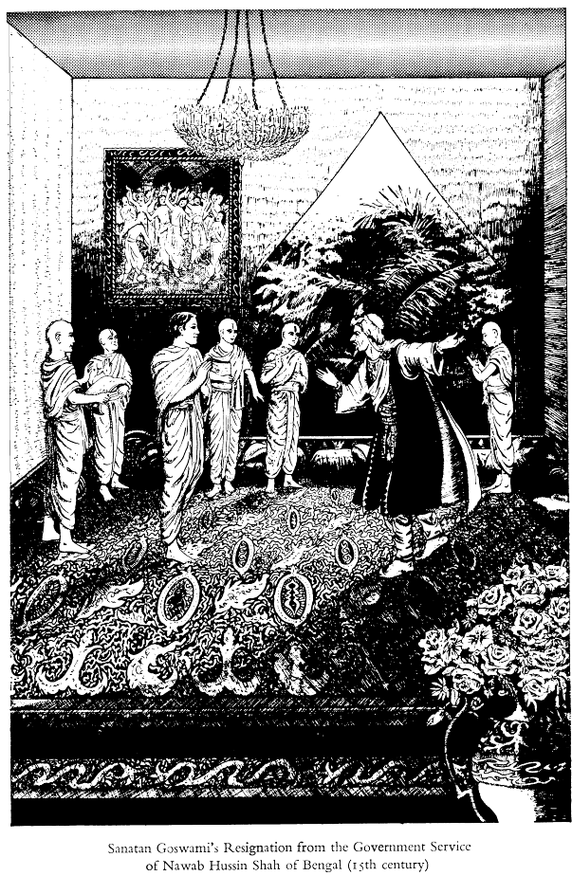
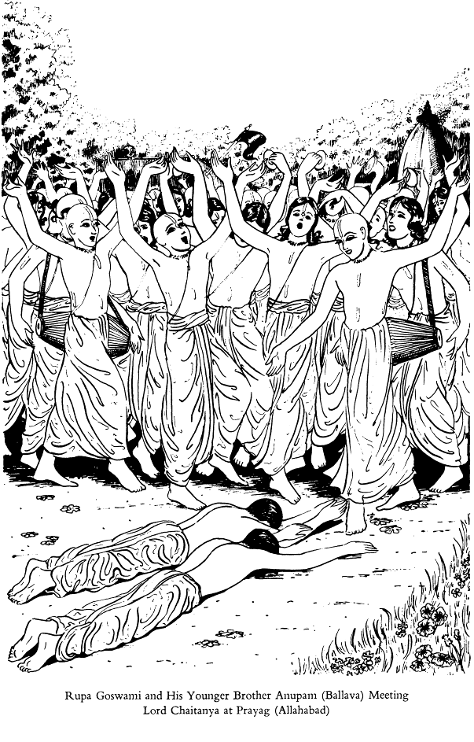
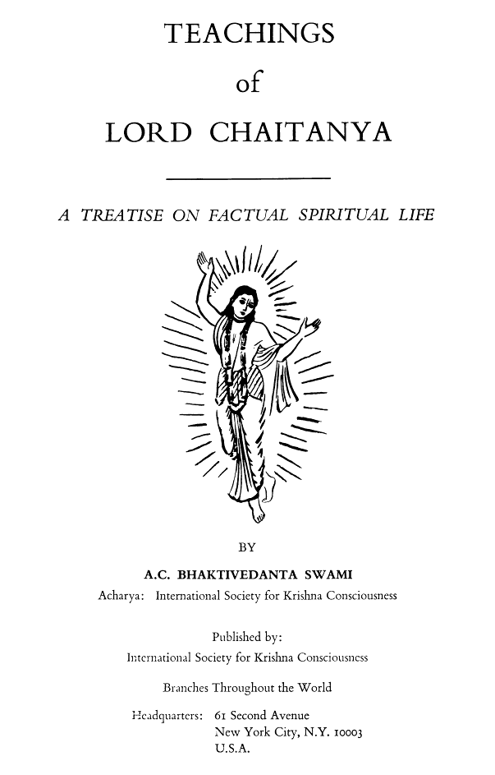
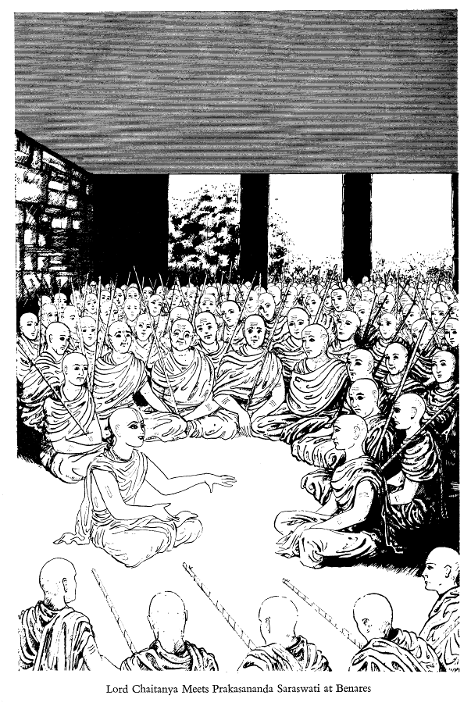
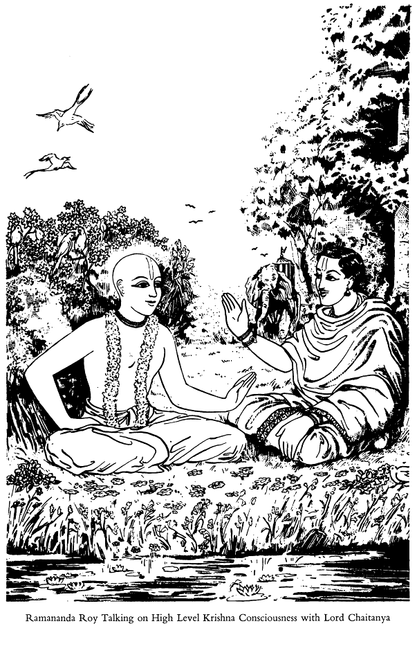

For example, the picture of the angry Kazi who comes to find Rupa Goswami staying home from work to recite Srimad Bhagavatam, along with Brahmins, was described by him exactly. “Make the room very opulent, as they were receiving large salaries in the employ of the Muslim government,” is an example of one directive. “The kazi should appear very angry; he depended upon them to run his government, and they did not come for their work.” This is another example.

Another one that I recall is, “Both the brothers fell flat before Lord Chaitanya, like a rod.” Another example, “Lord Chaitanya sat down at the door, by the shoe-keeping place, showing his humility and simplicity before the congregation of Mayavad sanyasins.” There are many such directives, and I took careful notes on most of them.

Most significantly, Swamiji’s guidance was essential for the picture of Lord Chaitanya fainting in the temple of Lord Jagannatha. No Westerner has been allowed in this temple, and I had never even been to India! Our only information was coming directly from Srila Prabhupada. He described that the temple was dark inside, except for the ghee lamps on the altar, and the priests were sitting atop the tall platform, where the Deities of Lord Jagannatha, Lord Baladeva, and Lady Subhadra also sat. This particular drawing was done slowly and carefully with many consultations with Srila Prabhupada--who was, after all, staying in the next room. So it was quite easy to consult with him on every detail!

During that same year of travel with Srila Prabhupada, 1968, I also did the line drawing for the cover of the first MacMillan Bhagavad Gita As It Is. This original Bhagavad Gita cover was to be a drawing of the Universal Form. It was a large line drawing, perhaps 18” x 24.” Because there was to be so much detail, I had to work large, so that it could be later reduced and still have clean lines. The drawing was to depict the thousands of heads and arms and hands of the Lord, with the four-armed figure of Lord Vishnu prominently featured in the center.

My drawing was completed and approved by Srila Prabhupada, but, unfortunately, MacMillan chose to edit my drawing down to a single Vishnu form. They chose to remove thousands of heads and arms from my drawing, as well as to remove thousands of pages from Srila Prabhupada’s Gita. The result was the small lavender paperback Bhagavad Gita As It Is, printed in 1969.

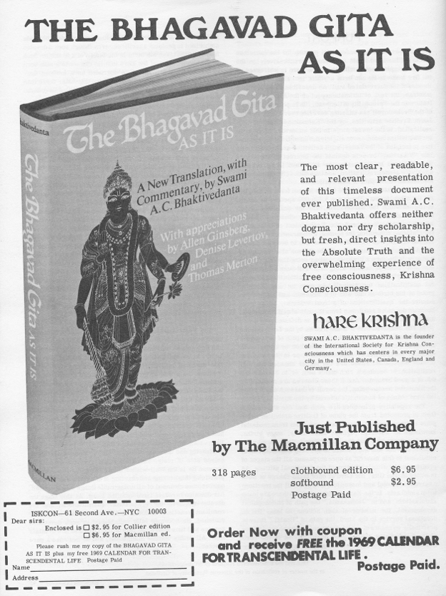

In 1969, though Srila Prabhupada’s manuscript for Bhagavad Gita As It Is had already been completed and had been given his final stamp of approval at that time, and even personally handed over to MacMillan for printing-- for financial reasons MacMillan chose to edit it severely, removing hundreds of pages of text. Since finances were limited, Srila Prabhupada accepted this severely chopped manuscript, saying “A blind uncle is better than no uncle,” a Bengali proverb that means, “something is better than nothing.” Srila Prabhupada often quoted this proverb when he accepted something that was less desirable.

But Srila Prabhupada was not at all satisfied with this severely edited Bhagavad Gita. He wanted his full manuscript printed. MacMillan complained of repetition in the text, which meant more cost; Srila Prabhupada’s argument was that repetition was necessary for teaching his students, and the world, this philosophy of Krishna consciousness. He was not very happy with their cutting edits, as he had completed his Gita as he wanted it printed in 1969, and did not want it changed.

So as soon as he was financially able to do so, he printed his complete and approved edition of Bhagavad Gita As It Is in 1972, along with his forward dated May of 1971. For Srila Prabhupada, this was the crown jewel of success.

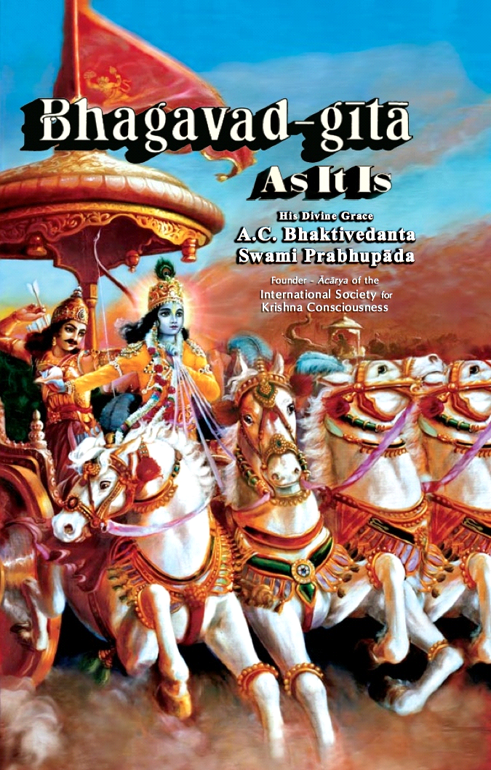

And this was indeed the beginning of mass book distribution. People were attracted to the mystical message of the Gita, with Srila Prabhupada’s colorful painting on the front cover, a painting of Lord Krishna, carrying his mystic conch, Panchajanya, into battle, and driving the chariot of Arjuna. This painting was designed by Srila Prabhupada, and executed by his apprentices, Jadurany and Baradvaj. This new unabridged and completely approved Bhagavad Gita As It Is was a great landmark in his preaching success!

Srila Prabhupada was very happy with it. He proudly showed it to guests whenever he could, and was often seen sitting in his room, reading it. He would comment with amazement, “Krishna has written these books! I have not written. Krishna Himself has dictated!”

During that year of travel with His Divine Grace, the year 1968, there were other incidents of artistic instructions as well. Even though I was not doing much artwork, as my time was filled with caring for Srila Prabhupada and typing his correspondence and transcription work, Jadurany continued to paint and would ask questions whenever possible. She wrote many letters to Srila Prabhupada, and since I daily took dictation of his replies, I became more and more conversant with what he expected of his artists.

On one occasion, when Srila Prabhupada and Goursundar and I arrived in San Francisco, there was a new painting of Narada Muni hanging on the temple wall. I was impressed. It was one of Jadurany’s latest works. Jadurany’s technique had improved immeasurably, and her proportions were also much better. Her colors were more subtle, so the painting showed great technical improvement over her past works. Looking at it from a purely technical point of view, as a trained artist, it was indeed much better than her work in past. So I mentioned it to Srila Prabhupada, commenting that “Jadurany has improved her oil painting technique so much!”

Srila Prabhupada glowered and winced. He said, “I do not very much like this new style painting!” I was shocked. This painting was obviously adapted from some Renaissance work of the old masters; it looked a bit like a figure from a Renaissance painting, that was then modified with an orangey saffron dhoti and a vina placed in Narada Muni’s hand. Technically, it was good.
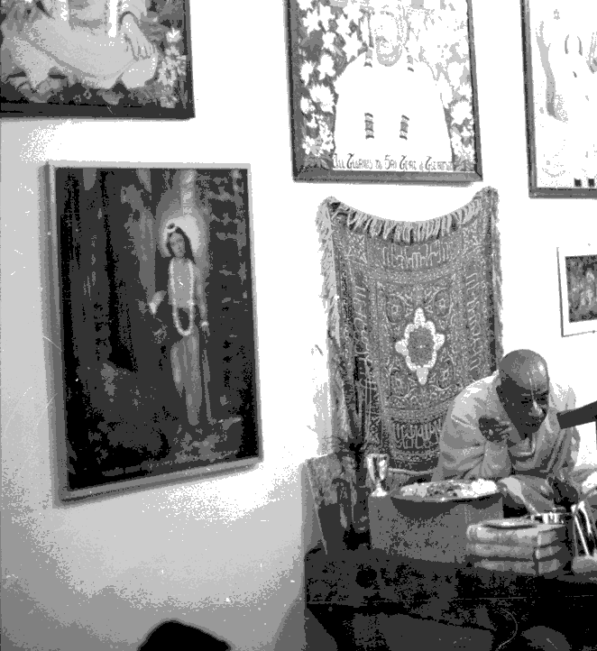

“Why?” I exclaimed. “What is it that you don’t like, that you find so distasteful?” I was truly concerned.

“Narada Muni is an eternal brahmachary!” Srila Prabhupada exclaimed. “She has made him look like a meat-eater and a woman hunter!” I was stunned.

Later, Srila Prabhupada explained this in more detail. He said, “Cheeks gone down. ‘Galtobra.’ This is the face of a meat eater, and a womanizer. And a wine drinker!” I noted that the figure did indeed have a lustful and wanton look about the face. It was not a face full of spiritual luster and innocent beauty.

While sitting in front of his desk, taking dictation for a letter to Jadurany, he explained further. I asked, “So, how should this be corrected? What should his face look like? What needs to be done?”

Srila Prabhupada pointed to a Brijbasi print hanging on the wall near his desk. “Like this,” he said. “These are the faces of milk-drinkers, rounded and beautiful. They have moon-like faces!” He explained that Krishna has the “moon-like” face of a milk-drinker, and so do His servants like Narada. No “nonsense muscles,” or “squared jaw,” as is shown in Western art, especially in Renaissance art. Renaissance artists, such as Michelangelo, were famed for their elaborate portrayal of the musculature of the human body.

Even in art school, I recalled, the female face was said to be rounded, like an egg, and the male face was said to be squared off, like a flower pot. This was indeed what the old masters taught. But Srila Prabhupada wanted all the faces to be round and full. My husband did not particularly like my drawings of moon-like round faces; he sometimes teased me, calling them “balloon faces,” and “balloon figures.” But this is what Srila Prabhupada liked, this is what he wanted, and he clearly did not like the figures from the Western schools of art! He wanted us to use for reference the Indian styles of art, showing the beauty of the “transcendental form.”

And, it suddenly dawned on me, the people of that era, the European Renaissance, were indeed meat-eaters, wine drinkers, and womanizers! I quickly contacted Jadurany, and she created her future paintings based on Srila Prabhupada’s instructions on this, and his explanation of “galtobra.”

Perhaps it was safe to assume that we could draw upon European art for some things, but not for all. And certainly not for figures or for faces! Nor for the dark and foreboding colors often found in the backgrounds of old masters’ paintings. Dark surroundings were not to be a prominent feature in our transcendental art style.

Transcendental art, Swamiji explained, was meant to depict the spiritual world. That means it has to be bright, shimmering, colorful, and effulgent. The faces and figures should be soft and supple, rounded and child-like, full of innocence and sweetness. The backgrounds should be bright and full of colorful beauty, with birds and flowers gracing every part of the landscape. Since Swamiji had the vision and experience of the spiritual world, and how it was to be depicted--and I certainly did not--I tried to model my artistic style after what he wanted. That should be the goal of any artist who is attempting to paint transcendental art.

Another incident took place while we were staying in Los Angeles. Srila Prabhupada wanted Goursundar and I to make Deities of Gour Nitai, dancing with upraised arms. To do this, we first had to perfect a drawing that was approved by His Divine Grace. Because my husband Goursundar was more expert with male figures, this drawing was first done by him.

Goursundar had studied male body structure, and had also been a weight trainer, so he knew the exact muscles that would show in upraised arms. He carefully drew the upraised arms of Lord Chaitanya and Lord Nityananda having some very gentle hint of muscles, both in the upraised arms and in the upper chest. The muscles were not very pronounced at all; they were quite subtle, only hinted at.

But Srila Prabhupada immediately nixed it. “No! No muscles showing!” he said. “This is not transcendental form--this muscles, this is human form. Human bodies have muscular forms, but not transcendental bodies. They are smooth and beautiful.”

Srila Prabhupada explained that transcendental form is always smooth and graceful. “Arms like the trunk of the elephant,” he described. Muscles and veins should never be shown in pictures of Krishna or any transcendental beings.

“This fleshy muscle and vein form is the body of human beings. Not transcendental beings!” Srila Prabhupada taught that we could not simply take a photo of a human being, and paint it blue for Krishna, or golden for Lord Chaitanya!

Rather, he explained, the transcendental form has long sloping arms, like the elephant’s trunk, delicate hands, graceful feet, large head, high forehead, arching brows, waving hair, lotus eyes, and curved, sweet smiling lips. The transcendental form does not look at all like the mundane beauty of human beings.

There are many examples of this in Indian art. South Indian sculptures show the graceful beauty of transcendental form, as well as the classical paintings of the famous Nathadwar painter, B. G. Sharma. In the Vedas, there are even examples given, such as “hair like a snake” (wavy dark hair), “moon-like face” (rounded sweet face), “lotus-like eyes” (eyes elongated and lovely like lotus petals), “nose like a parrot” (graceful aquiline nose that slopes down slightly--not like the turned up human nose), “eyebrows like bows” (eyebrows arched and smooth like the bow and arrow), “lips like the bimba fruit” (plump, reddish and sweet) “arms like the trunk of the elephant” (long, slender, smooth and rounded), “neck like a conch” (rounded and smooth), “chest like a conch” (rounded and curved toward the waist), “thighs like the elephant” (strong smooth thighs), and so on. Some of these descriptions are actually described in Vedic texts, such as the Shilpa Shastra, and are designed to guide transcendental artisans in both painting and sculpture.

During the time we were with Srila Prabhupada, from January of 1967 until March of 1969, there were numerous other sketches and illustrations I was told to do. One that comes to mind is the design of the “certificate” for his planned Bhakti Shastra program--this was planned even before his first MacMillan Bhagavad Gita was printed. Srila Prabhupada designed it with small pictures in each corner, of himself and of Lord Krishna as well. It was used early on, but not widely distributed. I still have the original design he gave me. Because the calligraphy had to be done by hand, it was too time consuming. However, he did plan this certificate to be given to all of his disciples, and all of those who completed his Bhakti Shastra program. One example is here, given to my senior Godbrother, Rupanuga dasa.

Another small project was a cartoon, which he entitled, “Child of Kali Yuga.” In this cartoon, he described that there is a mother, a father, and a child sitting at the dinner table. The mother is trying to feed the child milk, but the child is reaching for his father’s cigarettes and liquor. This was to be a small cartoon printed in Back to Godhead, illustrating the degradation of the Kali Age, but I don’t think it was never used.
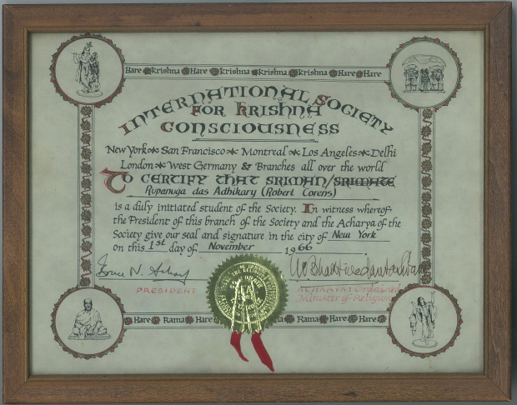
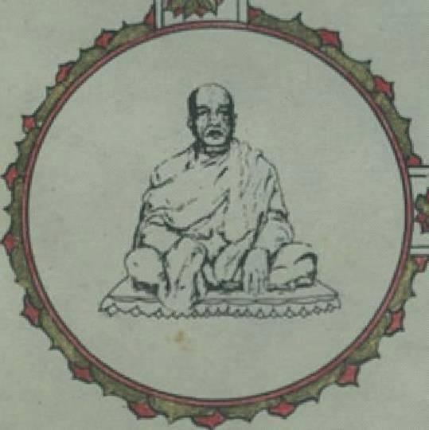
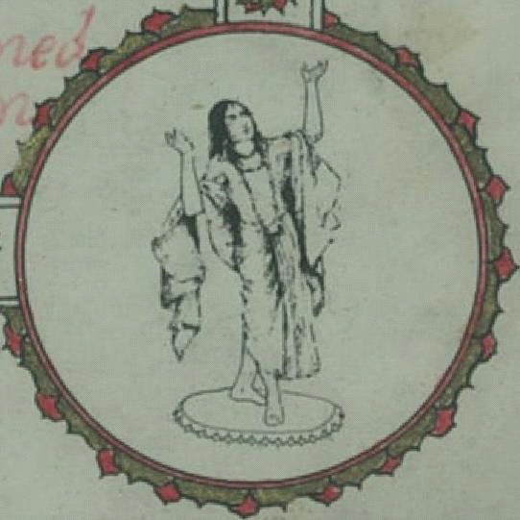
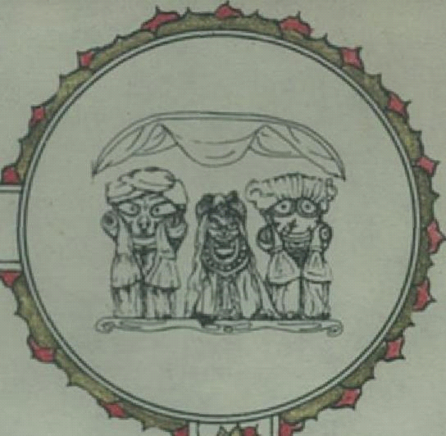
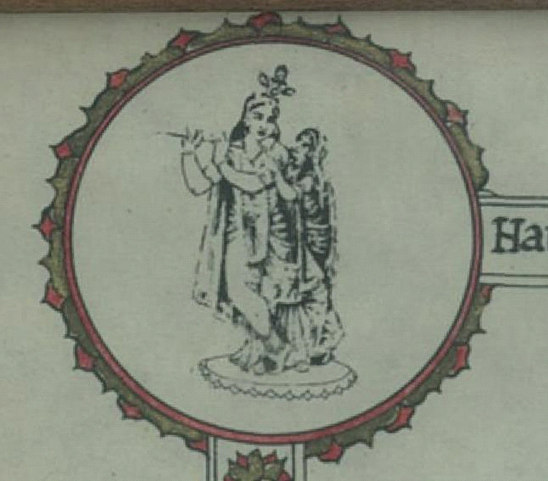

There was another more elaborate cartoon called the “The Story of Dr. Frog.” This was, of course, a cartoon series illustrating the famous story of Dr. Frog, who could not see beyond the walls of his little well. It was to illustrate the materialists’ narrow-minded perspective that prevents them from perceiving the spiritual realm. This was also to be printed in Back to Godhead, but I don’t think it ever was. We did, however, print it in our small newsletter, New Navadwip News, that we distributed in Hawaii. I still have the printed copy, as well as the original artwork of this illustration.
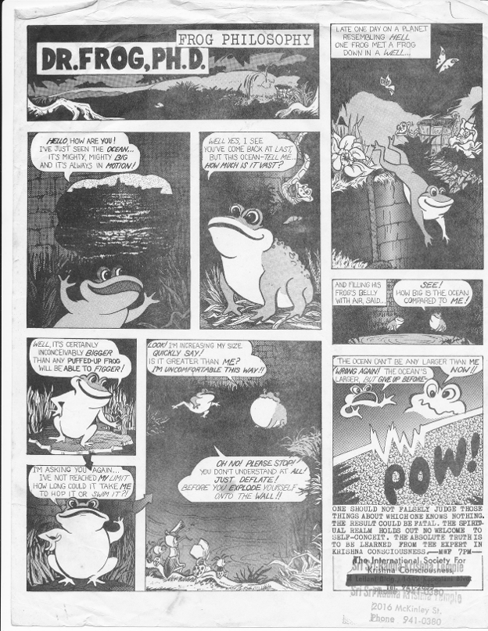

There were other small projects, for example, designing altars, ratha carts, and so forth, too numerous to mention. One very noteworthy project, however, was the illustration of Lord Vishnu on Garuda. This was one of my favorites, since I am so fond of Garuda. Srila Prabhupada described that we should show in the painting that when Garuda flaps his wings, the sound vibration of the Hare Krishna Mahamantra is “coming out with each flapping of the wings.”
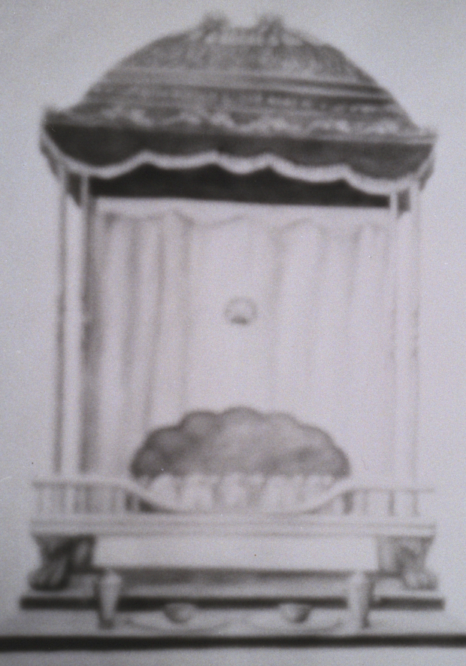

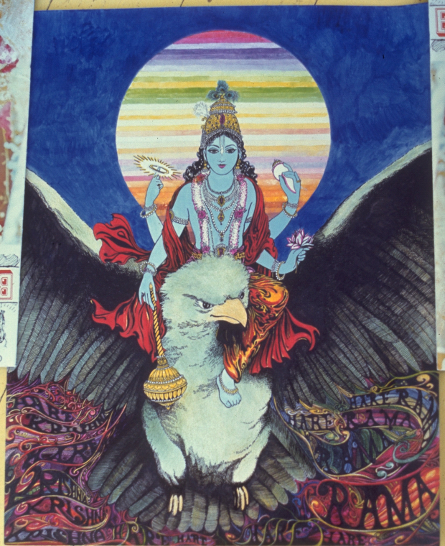

This picture was done while we were with Srila Prabhupada, and Goursundar and I worked on it jointly. I drew the Great Bird, Garuda, and the Vishnu figure, and my husband did the background showing swirling sound vibrations coming from the wings of Garuda. It was also to be used in Back to Godhead, along with Srila Prabhupada’s elaborate description, but I don’t think it was ever printed either.
In January of 1969, Srila Prabhupada sent me to Hawaii to open temples in the Islands. He named the Hawaiian Islands “New Navadwip” after the nine islands of Navadwip Dhama. He joined us soon after, in February and March of 1969, and spent about a month with us in a seaside house in Kaaawa, on the Eastern shore of Oahu.
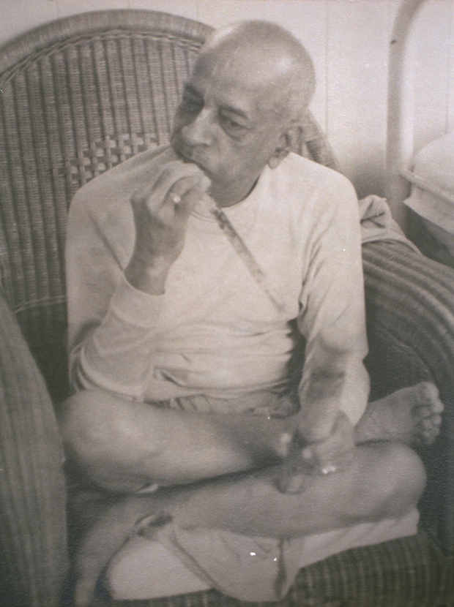
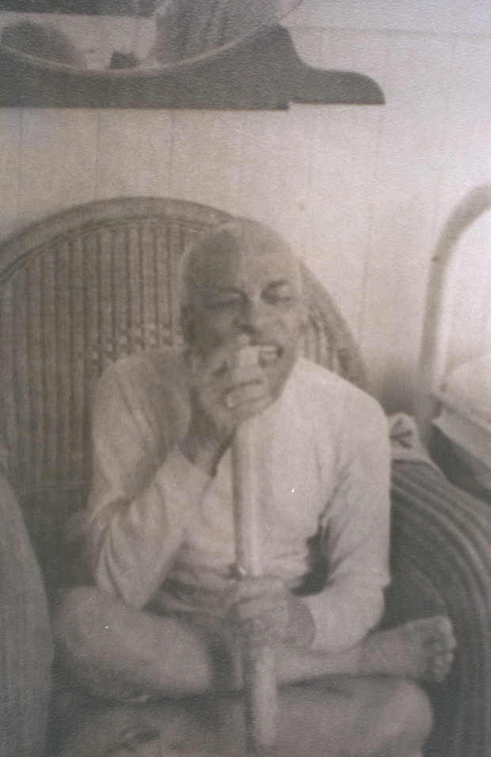

During that time, he enjoyed walking daily to a nearby beach park, as well as eating fresh sugarcane from the fields. There were many more discussions during that initial visit to Hawaii, not only on transcendental art, but on his Bhagavad Gita as well. At that time, Srila Prabhupada was greatly disheartened by one disciple’s refusal to translate his Gita into another language, unless he received money to do so. This was a great disappointment for Srila Prabhupada; it showed a lack of basic understanding of Krishna consciousness philosophy.
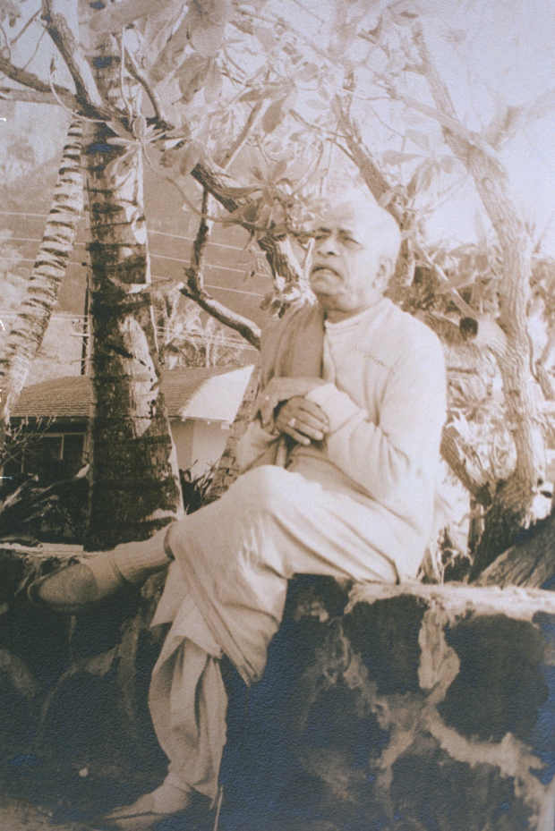
Sadly, it was also the beginning of a new philosophy: the philosophy that one can be paid for doing devotional service. It is an erroneous concept, Srila Prabhupada explained: “Either you get the money or you get the bhakti. You don’t get both.” Serving the Spiritual Master is a voluntary thing, and if one is paid to do it, it simply becomes a job. The consciousness changes, and from that perspective, it then becomes self-interested material consciousness, not Krishna consciousness.

Srila Prabhupada wanted everything to be done exactly as he prescribed, down to the details, without our taking it upon ourselves to create something new, or to in any way change things. This was always his greatest criticism of our Western culture--that we would take things cheaply and change them or edit them according to our limited understanding. Or, as he would often say, “according to our whims.” He even once said, about his Western disciples, “Next, they will be asking me if they can kill cows to make mridangas!”

Once the Hawaii temples were established, I began to paint again. I did several large paintings for our temple walls. One was of Lord Brahma bowing before Lord Krishna, offering the prayers of Brahma Samhita. It still hangs in Srila Prabhupada’s bedroom in the Honolulu Temple at Coelho Way. Another was a medium sized Gour-Nitai painting, which became the main “Deity” picture on our altar for many months, prior to the installation of the Sri Sri Pancha Tattva Deities.
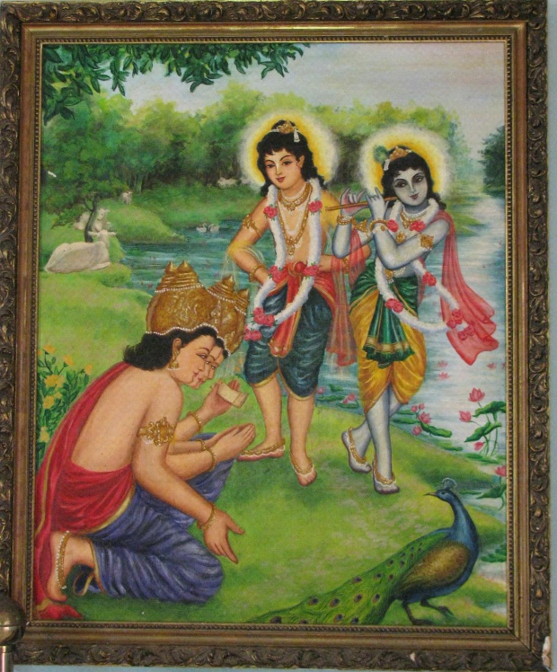

Soon after, on a visit to see Srila Prabhupada in Los Angeles, he asked me to make Gour Nitai Deities for our Hawaii temple. He raised his arms to show me how to pose Them, and even selected the exact color of paint on a Sherwin Williams paint brochure! (he indicated the goldenrod color with a check mark; I still have that same paint brochure to this day.)

Truthfully, I had no idea how to go about this work, as I was more of an illustrator than a sculptor, but Srila Prabhupada said confidently, “Krishna will guide you from within your heart how to do it.” Gradually, I came to understand that Srila Prabhupada was also guiding me within my heart as well--since I don’t really know Krishna, but I do know Srila Prabhupada!

This is the essence of the truth; Srila Prabhupada was able to guide us from within our minds and hearts from wherever he was. He didn’t have to be in the same room to do so. He would guide, we would present, and he would correct. This was true in all spheres--painting, drawing, sculpting, cooking, editing, and preaching. In a most amazing way, Srila Prabhupada was micro-managing his entire movement on every level! All we had to do was cooperate, and resist the temptation to change, modify, or correct whatever he was doing. We simply accepted that his vision was unlimited, and ours finite.

So, given this new project, I returned to Hawaii, and my husband Goursundar immediately constructed the metal armature for the Deities. This sculpture project took several months, but with the help of several of our wonderful Hawaii devotees, especially my dear sister and friend, Kusha devi, it was finally complete. We took photos of the finished Deity of Lord Chaitanya, and sent them to Srila Prabhupada.
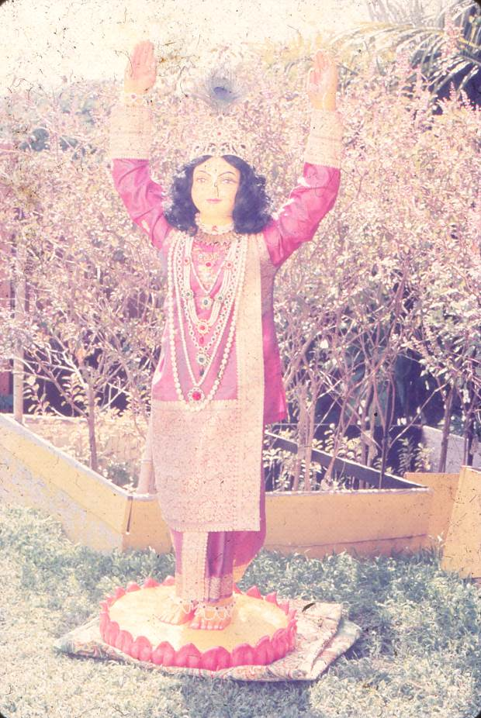
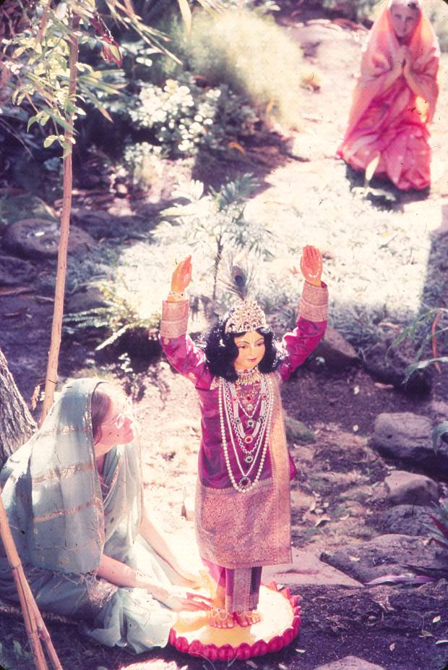
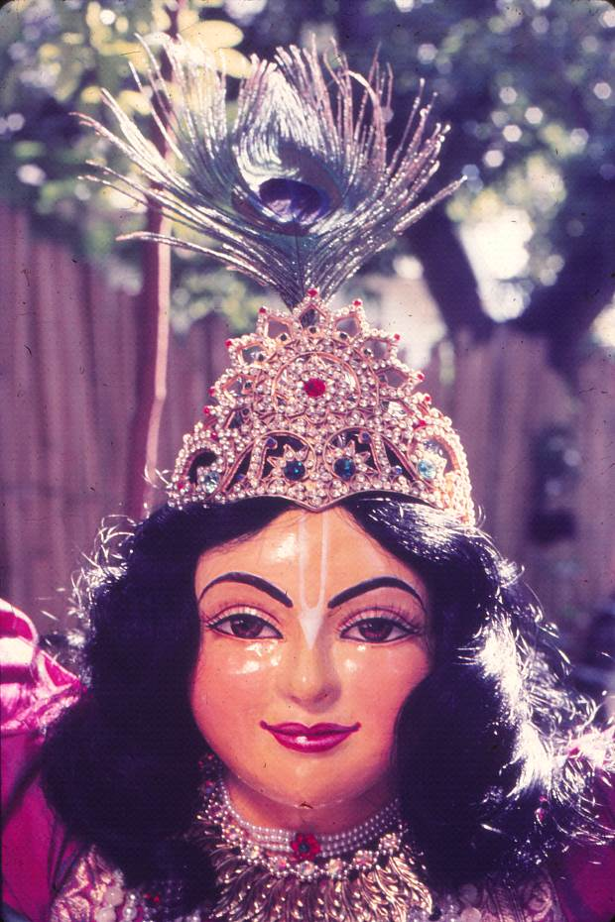

He received the photos of our Deity, and wrote back that he was indeed quite pleased. However, he also added that he would like us to now make deities of Sri Advaita, Sri Gadadhar, and Srinivas, as well, thus creating the Pancha Tattva Deities for Hawaii. This was the first instruction for the worship of Pancha Tattva ever given by him!

So we went back to the drawing board and made Pancha Tattva. Fortunately, by now, a very gifted sculptor, a grad student at the University of Hawaii, had joined us. Initiated as Vrishni das, he was a great help in making the molds and casting the forms of Sri Pancha Tattva. This was another gift from Srila Prabhupada, helping us in our service.

At long last, nearly a year later, when the Pancha Tattva deities were finally completed, Srila Prabhupada came to Hawaii to install Them. That was in May of 1972.

Srila Prabhupada spent over a month with us at the beautiful seashore at Waimanalo, Oahu, enjoying daily walks on the beach. Goursundar and I stayed in the servants’ quarters, next to the main beach house, where Shyamsundar, Pradyumna, and Nanda Kumar served Srila Prabhupada for that month in Hawaii. It was a wonderful month of festivals!

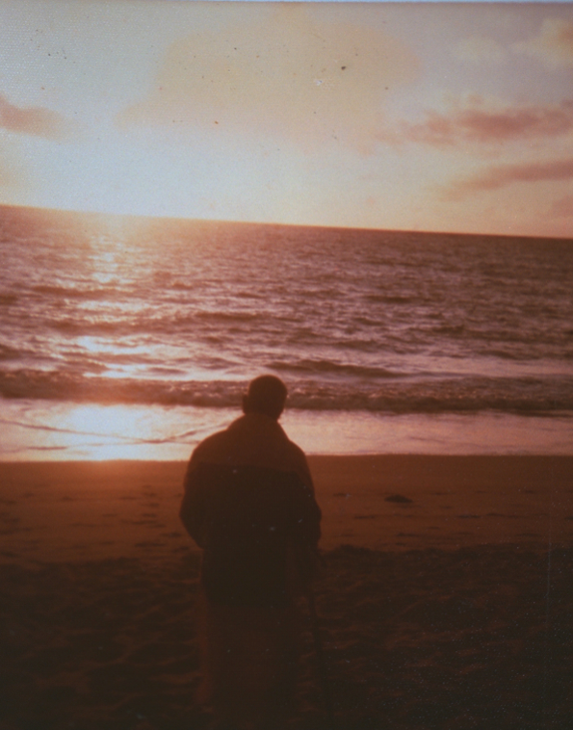
After the Pancha Tattva Deities were installed, I placed my painting of Gour Nitai on Srila Prabhupada’s makeshift altar in the living room at the beach house. This painting had been the “Deity” picture on our Honolulu temple altar for many months. Srila Prabhupada sat before it each day, chanting his rounds in his rocking chair, or walking back and forth in front of it. He liked the painting very much. At the end of the month, he asked me for this painting
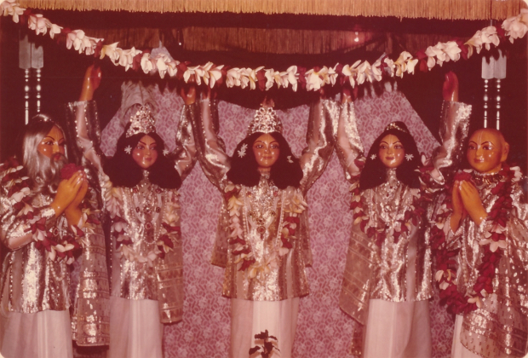
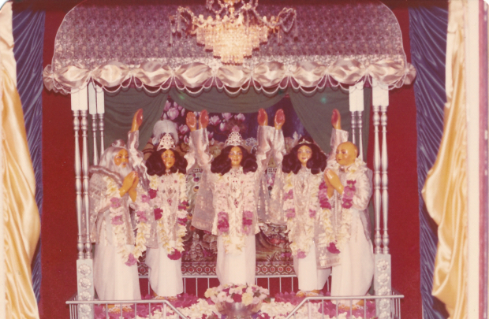

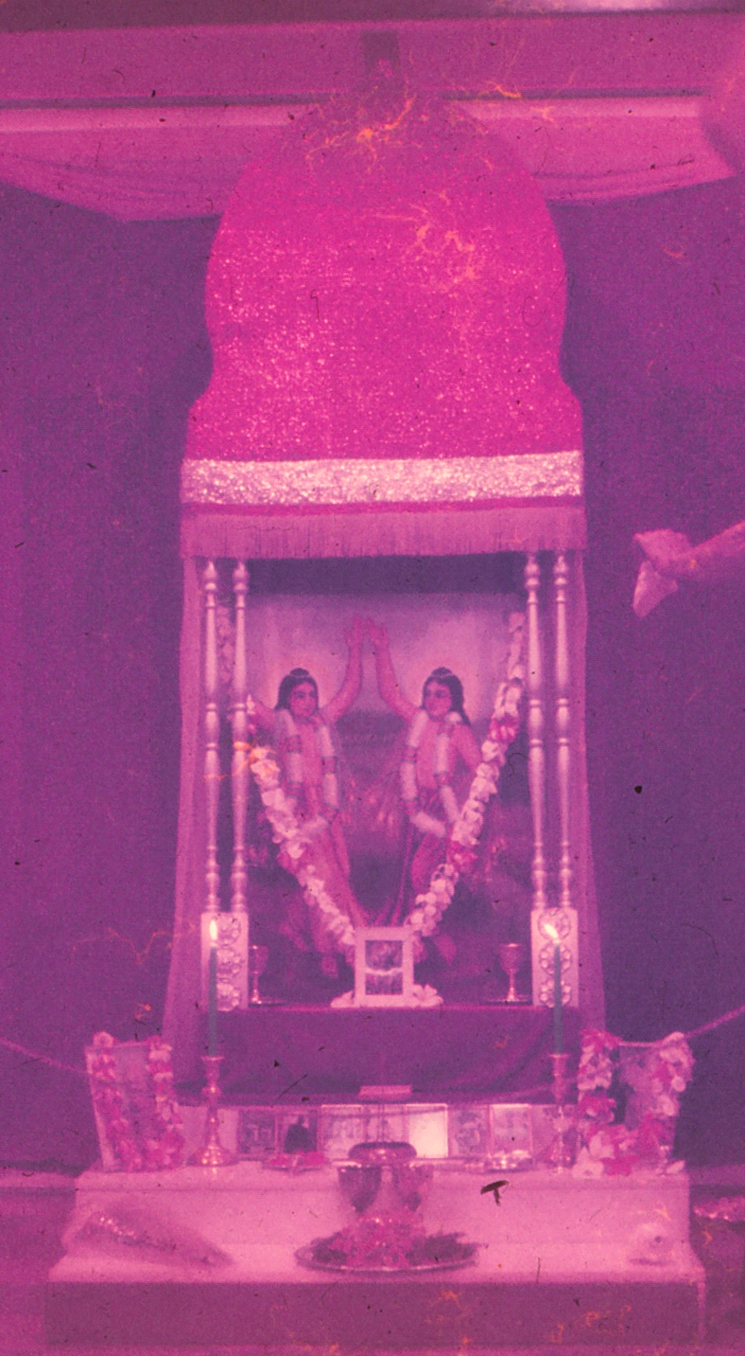

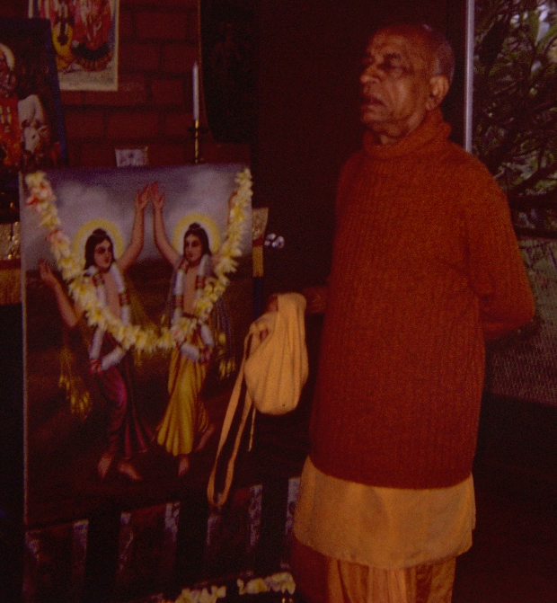

“Govindasi, what plans you have got for this painting of Gour Nitai?” he asked. “Now you have got your Pancha Tatttva Deities installed.”

“Oh, Srila Prabhupada, I have no plans. Would you like to have it?”

“Yes,” he replied, “I will take it with me to my rooms in Los Angeles.” And he did.

This painting of Gour Nitai still hangs in his bedroom in Los Angeles. He loved it very much, as it was rendered in exactly the style he liked, and imbibed with his own mood of devotion. This is the esoteric meaning of transcendental art.

Around that same time I also painted a huge painting of the Pancha Tattva, perhaps 4 foot by 5 foot. It hung in our temple room in the 1970’s; now it hangs in Srila Prabhupada’s room in our Honolulu temple.
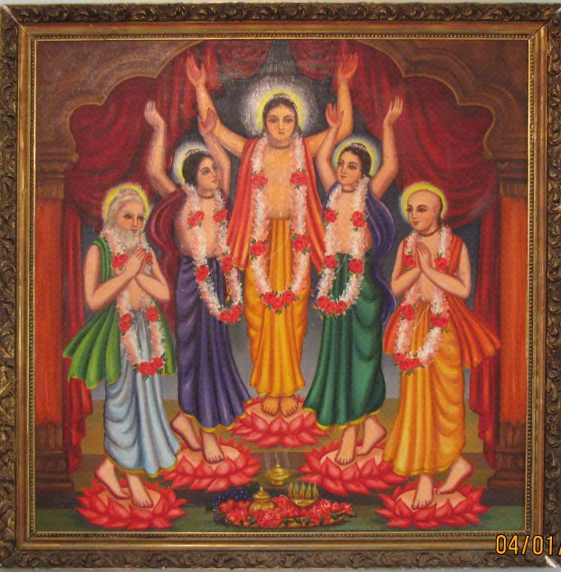

While creating that work, each evening as I painted, I did so with the mood that Krishna was working through my hands. Before painting, I would meditate on Krishna, and on Srila Prabhupada, and ask that Krishna’s beauty should flow through my hands and onto the canvas. I would gaze at my hands and see that they were tools only; tools to be used in His service. I always did this before beginning every art work, and still do this even now.

But I had a special desire while painting that large Pancha Tattva picture. I desired that this painting of Lord Chaitanya and His Associates would be so spiritually beautiful, and so full of bhava, that Srila Prabhupada would be extremely pleased, so much so that he would even place his head at Lord Chaitanya’s Lotus Feet. I had never desired anything like this before, and I never told anyone of this inner desire.

Many years later, this desire was fulfilled. It was in the late 1970’s. I was in Srila Prabhupada’s upstairs room at the Coelho Way temple in Honolulu. He was getting ready to leave for the airport. He was leaving Hawaii for some other preaching destination. The big Pancha Tattva painting was always hanging opposite his desk, so he could gaze at it while he worked. So he had to pass by it on the way to the door. Just when he came to the big painting, he paused, looked up at the merciful figures of Sri Pancha Tattva, then gracefully bent down to touch his head to Lord Chaitanya’s Lotus Feet. I was astounded. I did not say anything, but I remembered my desire. And now, my desire had been fulfilled.

And I knew he also knew that was my inner desire. He once wrote me a letter from India, saying, “I know your mind.” He knew everything within my mind and heart, and this was further proof of it. For example, he even knew that I loved the name “Govinda.” I had uttered it repeatedly while reading Herman Hesse’s book, Siddhartha, years before I met him, while still in college. So he named me “Govinda dasi” even though my first name started with a “B”, for Bonnie. In that moment, I was reassured that he not only knew my heart then, but for eternity as well. And I am grateful to have been so fortunate to have come in contact with such a great spiritual personality as Srila Prabhupada. Surely, there is no greater fortune in all the three worlds!

Srila Prabhupada’s letter to Jadurany, Sept 4, 1972, “If you think of me and work for me, then I am in your heart. If you love somebody he is in your heart. It is common thing, everyone understands it.”

Srila Prabhupada once explained to me that the Vaishnava Acharya is always in touch with his disciples. Because Krishna is in the heart of each and everyone, and the Acharya is always in direct contact with Lord Krishna, in this way, the Acharya is omniscient and omnipresent. Thus he is always able to be in contact with his disciples. Krishna enables him to see into their lives and to guide them as he sees fit. Srila Prabhupada assured me that this relationship between master and disciple is personal, and eternal, and that he, personally, will always be my Spiritual Master. I understood this philosophically, but this experience was added proof of this transcendental truth. And I bowed in gratitude.

Sometime in the mid-70’s, I did another series of paintings for what was to become the story of Dhruva Maharaj. This was a series of approximately 25 small paintings illustrating the Srimad Bhagavatam story of Prince Dhruva, designed for children. This was also done under the guidance of Srila Prabhupada. He looked at each one of my illustrations and gave his stamp of approval, and told the BBT to print this as a childrens’ book. However, it was never printed, as the project somehow got lost in the political upheaval after Srila Prabhupada’s departure from this world.
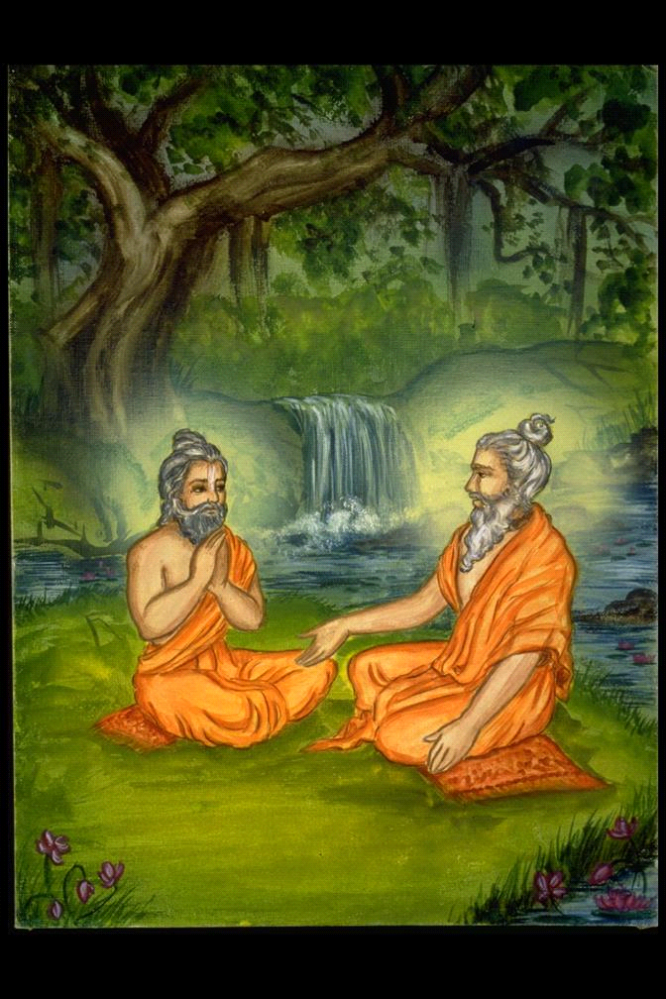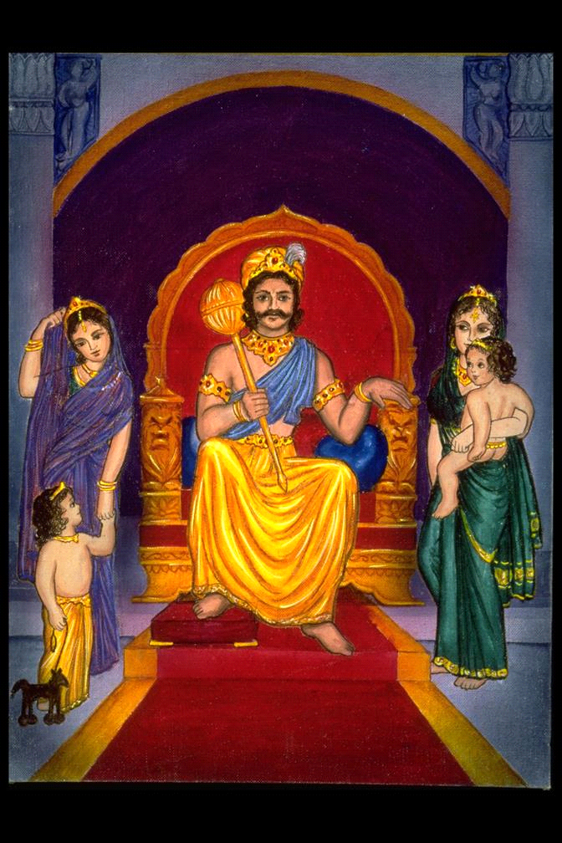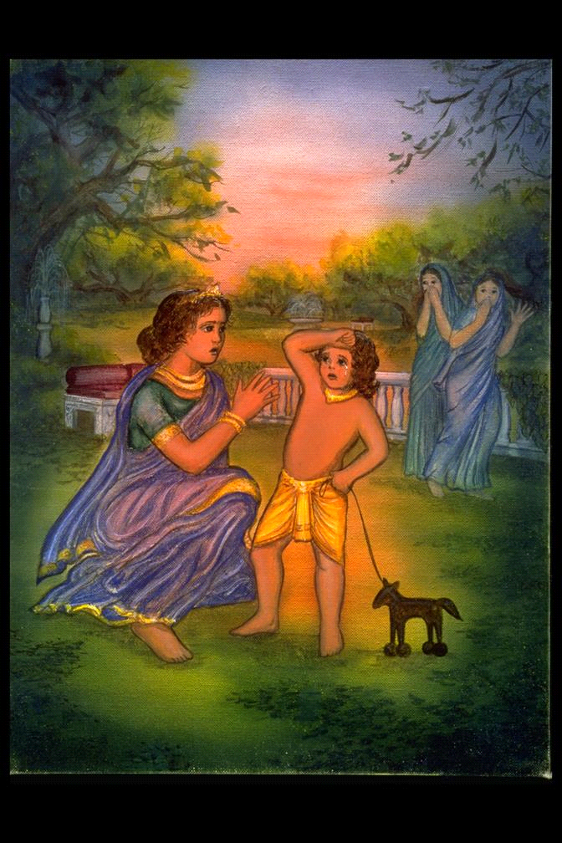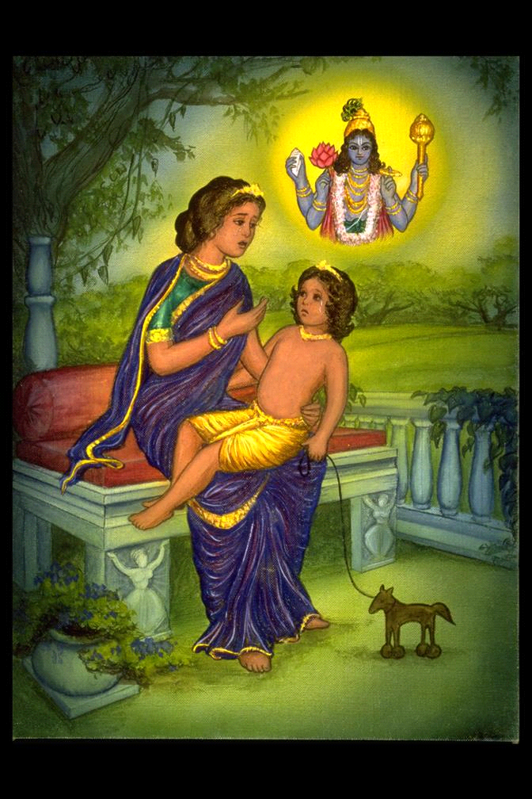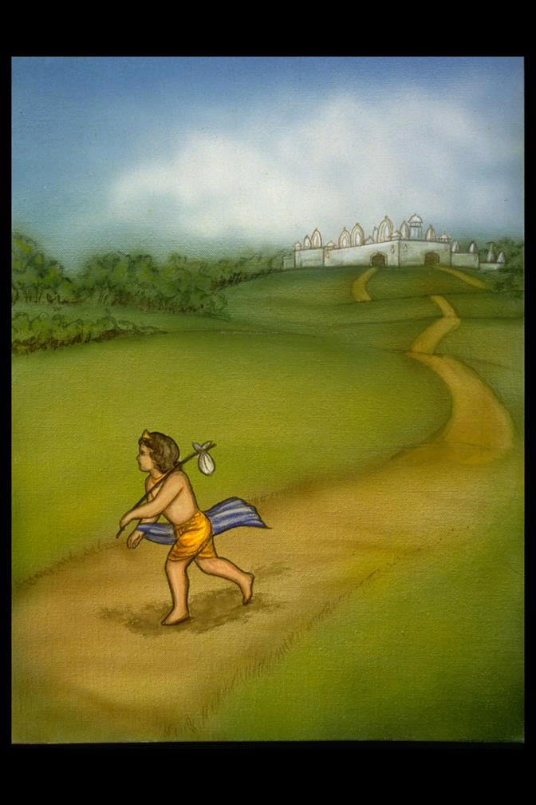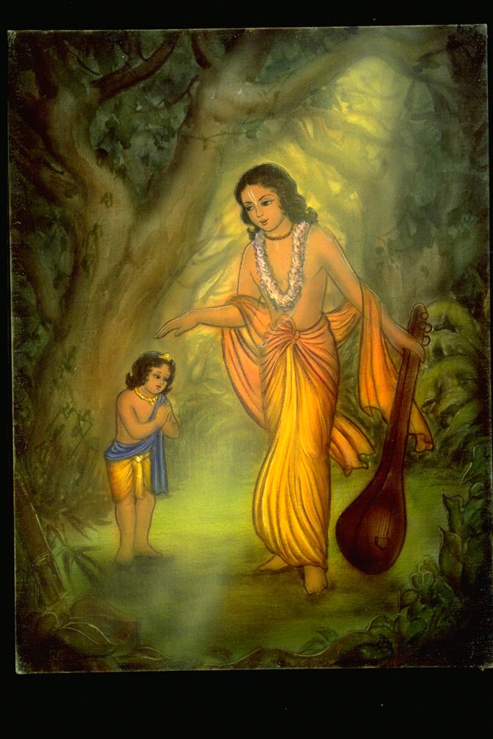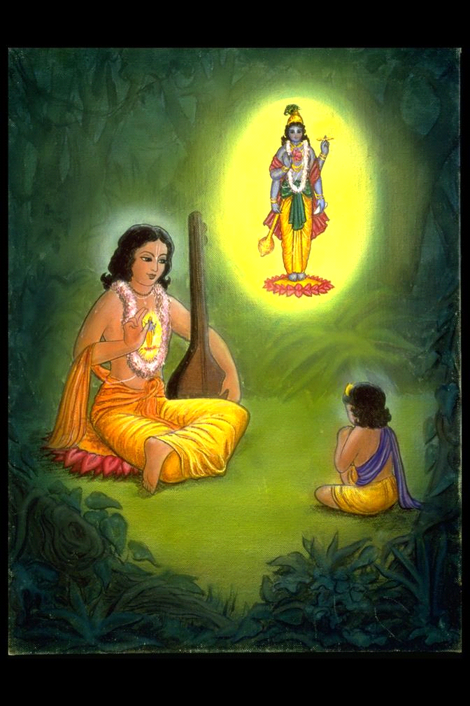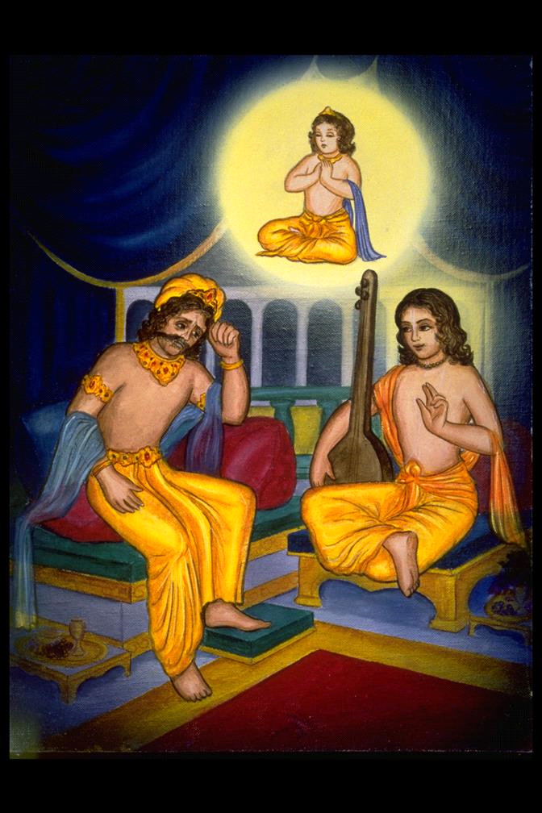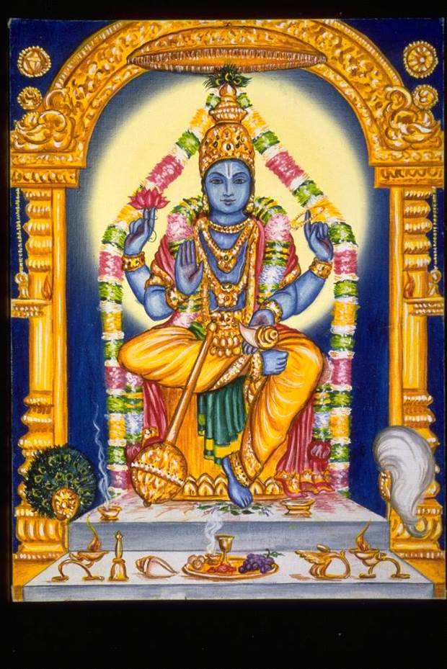
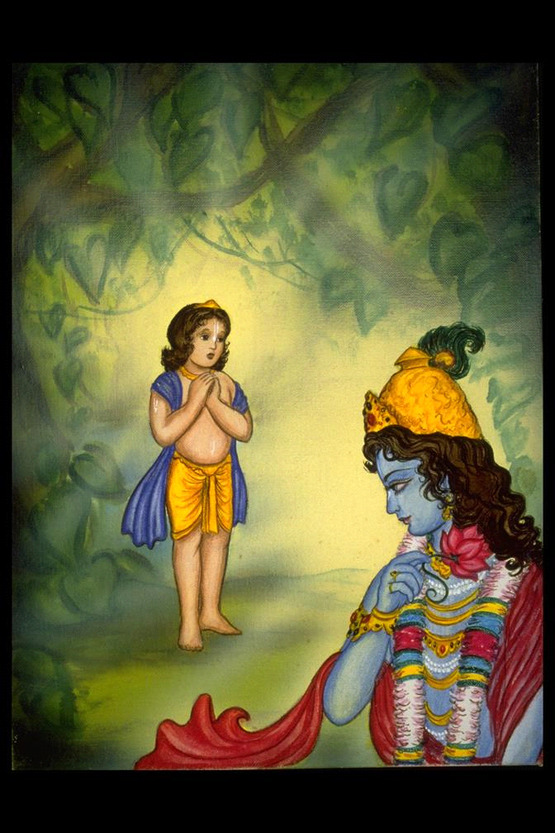
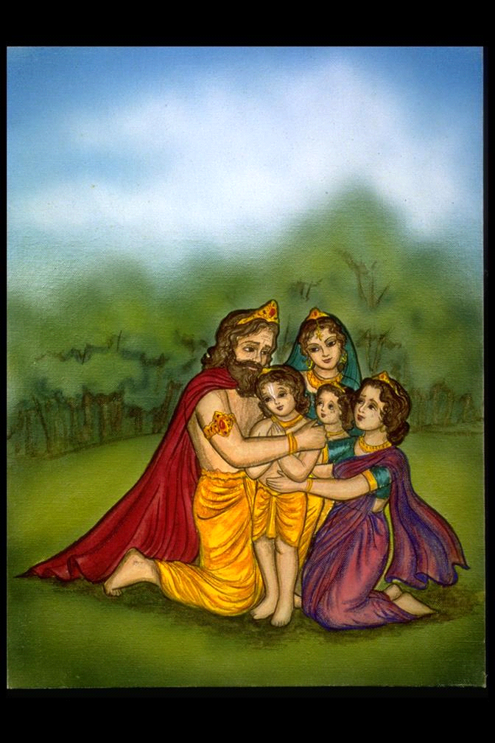
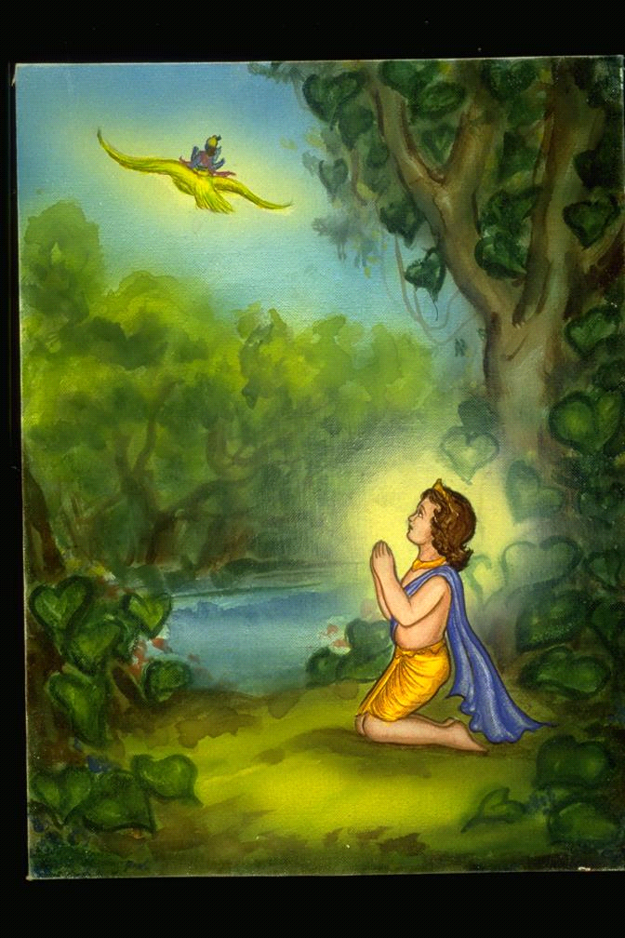
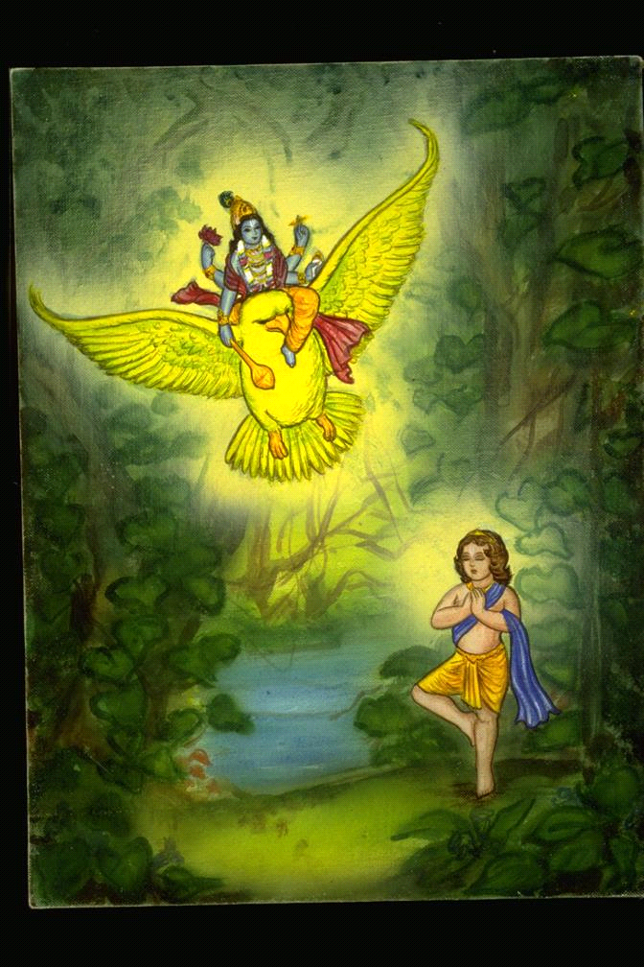
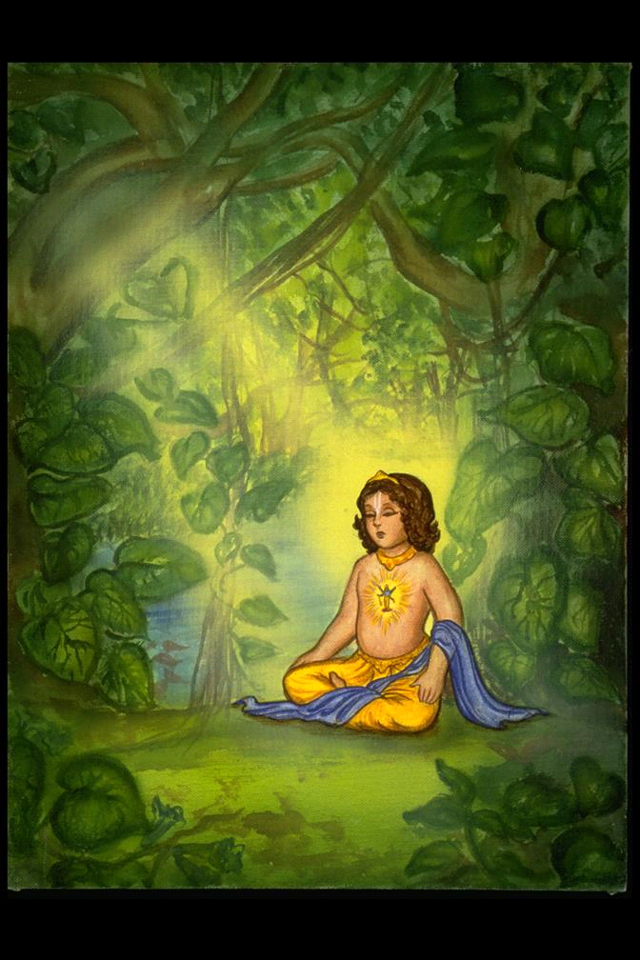
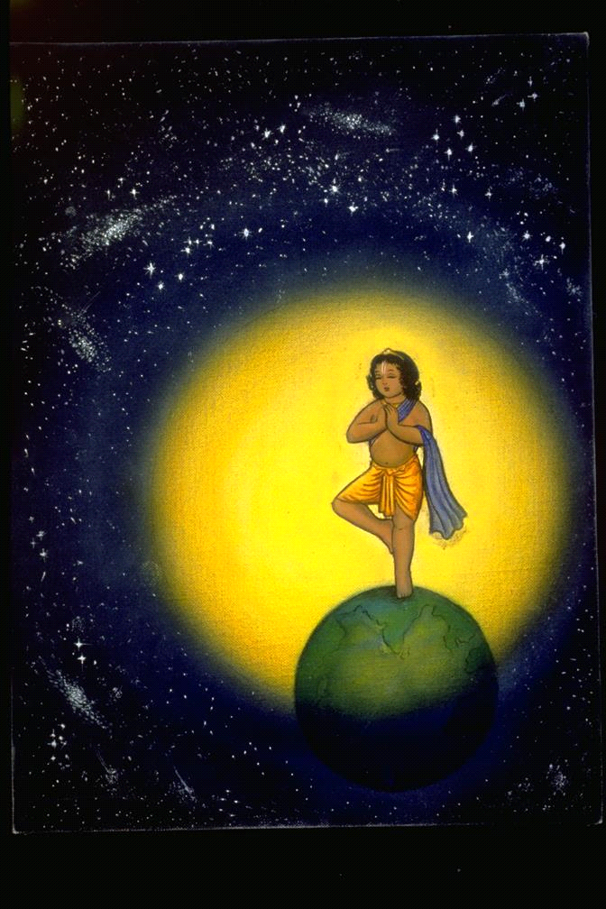
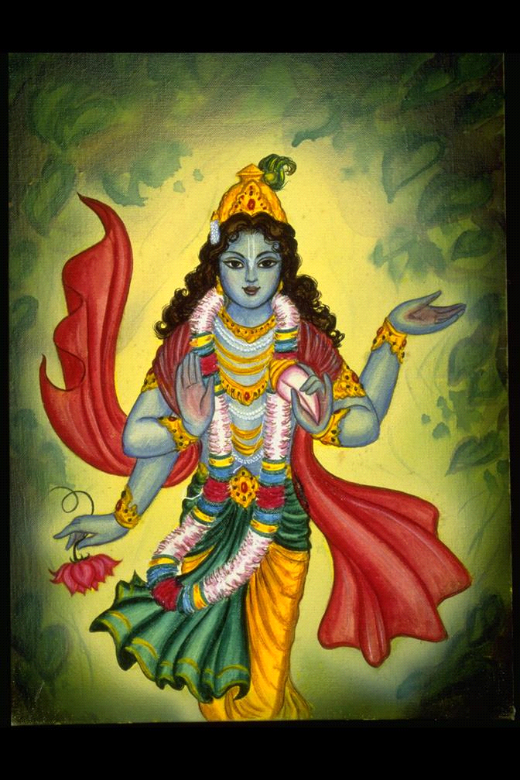
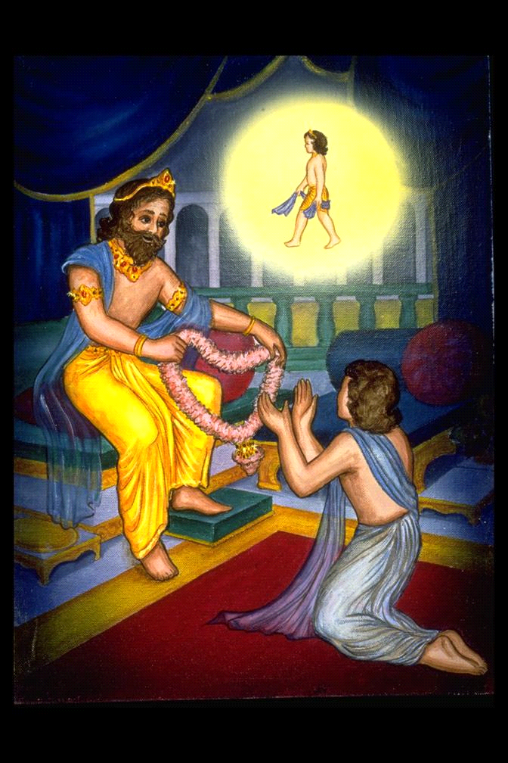
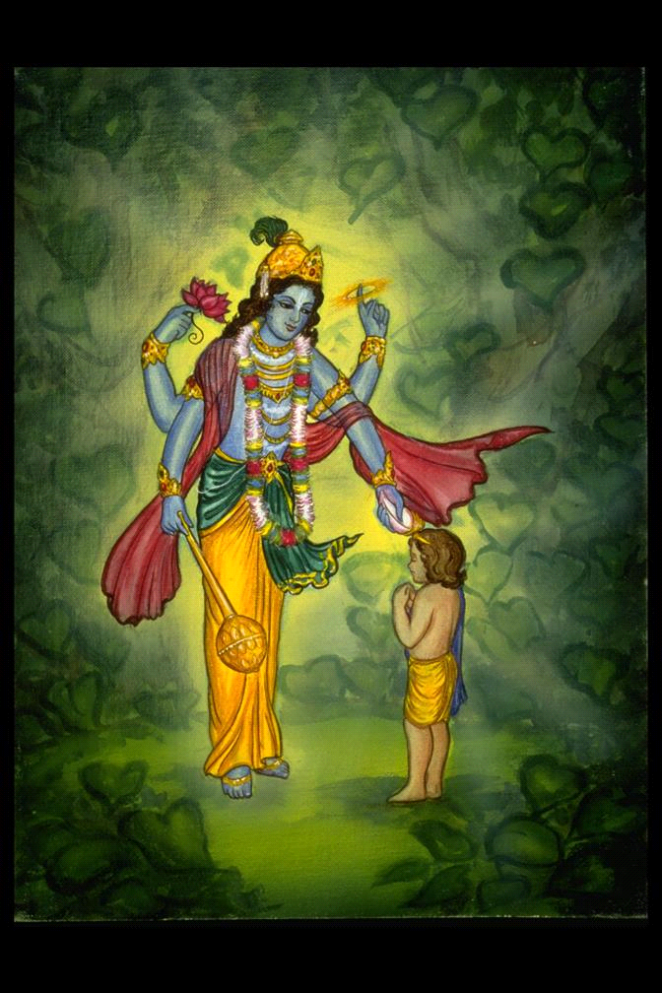
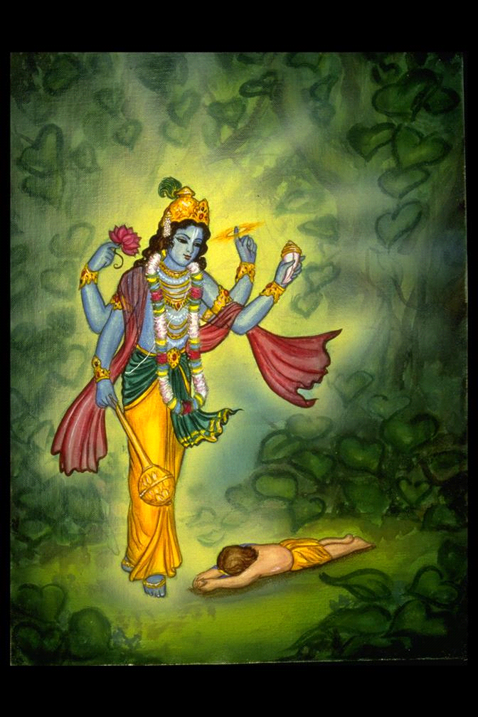
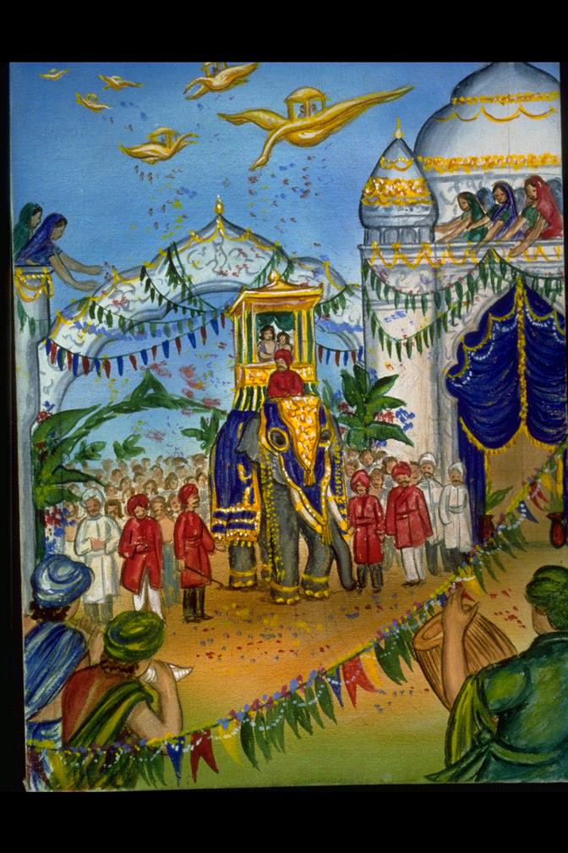

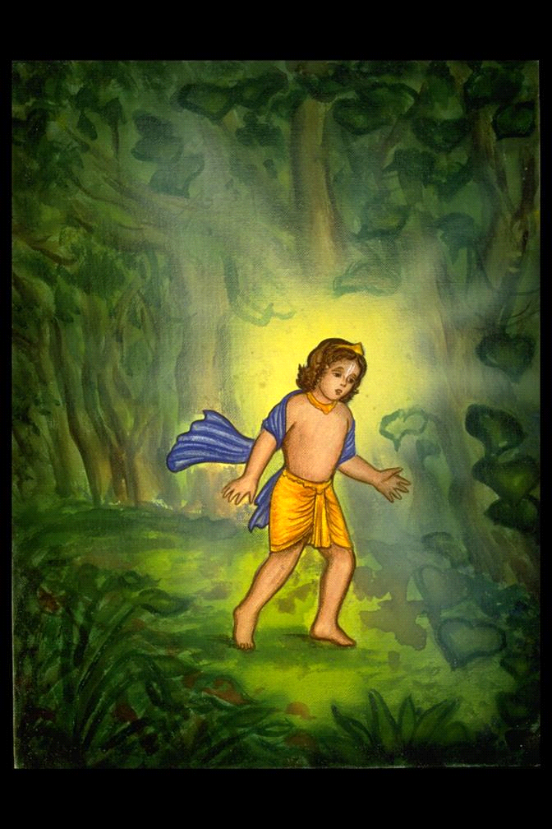
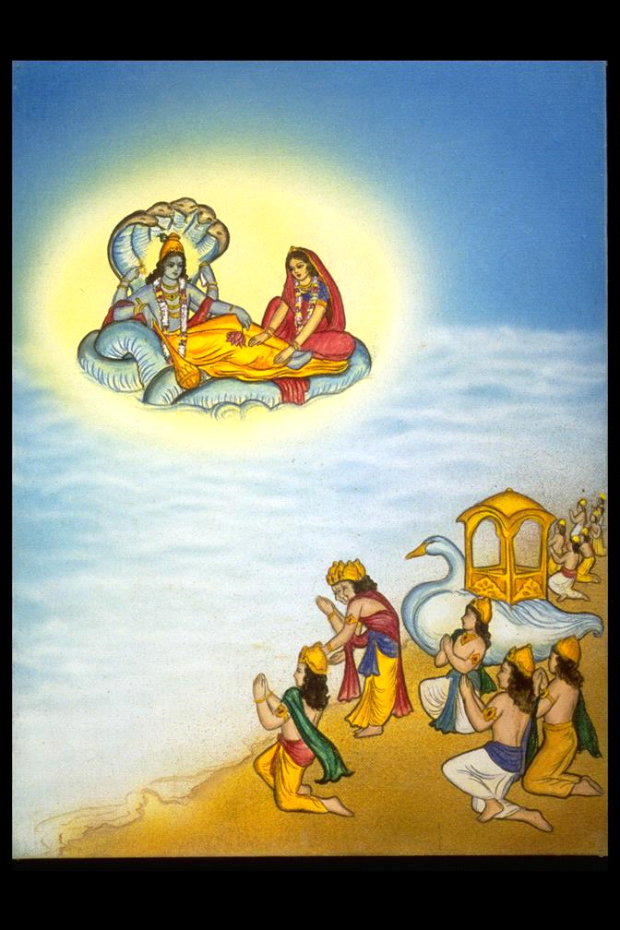
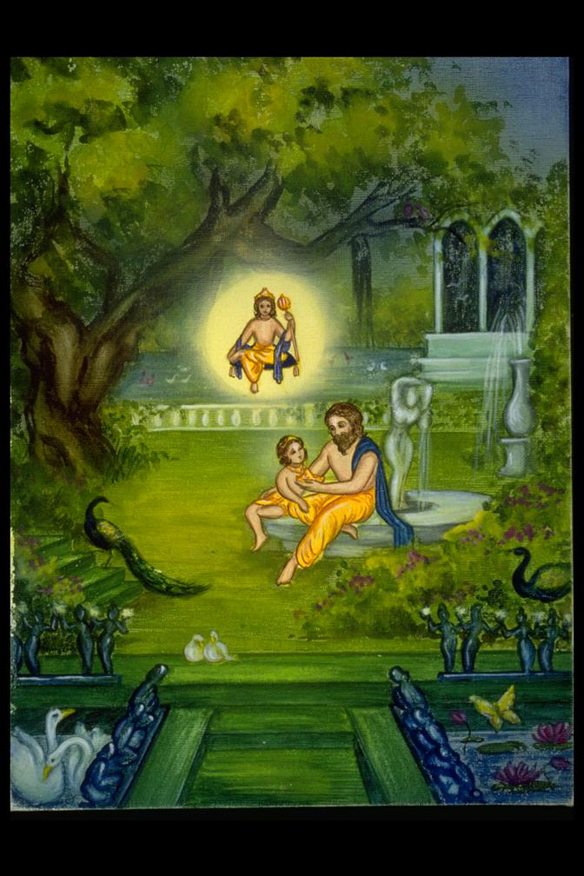
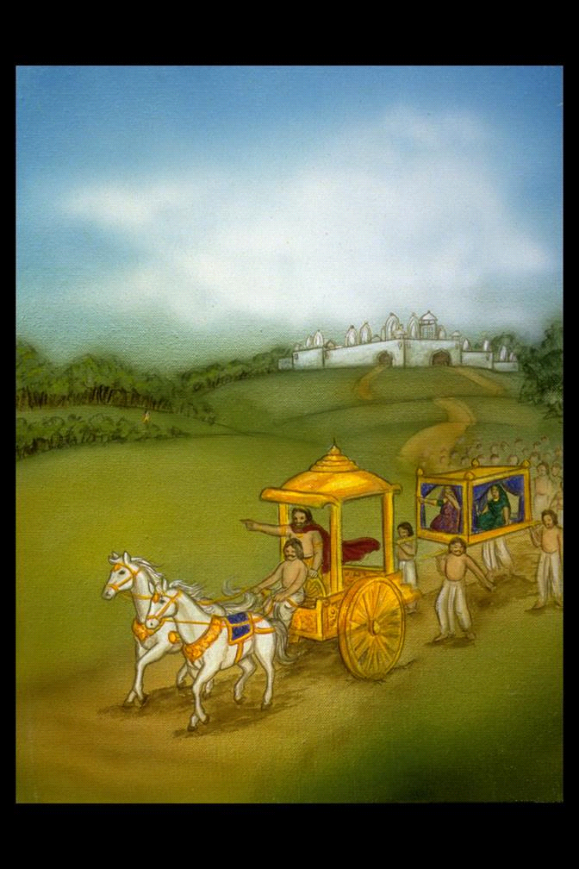

Because these were color illustrations, and the cost of printing color far exceeds that of printing black and white, I was never able to get this book into print. It still remains unpublished, after all these years, and in spite of the fact that it was Srila Prabhupada’s direct order that it be printed. It seems that at that time, ISKCON and the BBT had not yet realized the great importance of children’s books, and so they were relegated to a position of less importance. However, it is important to note that Srila Prabhupada himself, as early as 1967, started me on my first children’s book, in the form of the Prahlad illustrations. He could foresee the great importance of giving spiritual education to young devotees in the form of children’s books.

Since coloring books are much less costly to print, I later shouldered the expense myself and printed five coloring books: Gopal, Krsna, Nimai, Jagannatha, and Damodara. These books were printed by me, and I maintain the copyright, but Prabhupada’s original BBT (not the later company, BBTI) sold and distributed them widely in the 1980’s. They are still available from such mail order companies as Krishna Culture, and others.

My first coloring book, Gopal, was very well received by Srila Prabhupada. I traveled to Los Angeles to show him each of the illustrations before taking it to press. He was delighted. He laughed and pointed to several of the drawings, even showing child-like joy, especially when he saw the picture of Krishna with the butterfly. That drawing seemed to be his favorite. The expression of love in Krishna’s eyes, and the feeling of bhakti in the mood of the illustrations, was of primary importance to him. He wanted Krishna to be portrayed as very beautiful, very graceful, and very loving. He stressed these things far above technique. The “mood of bhakti” must shine through; otherwise, even it is technically excellent, it is a mundane picture that will not ignite the spark of the soul. That was the first consideration.

Later, I did more coloring books, Krsna, Nimai, Jagannatha, and Damodara. Certain devotees were a great help to me in this project. I am certainly indebted to Indra Pramad Prabhu, my “graphic arts guru” who was kind enough to take time to skillfully guide me in the technical skills and tools of production.

Indra Pramad Prabhu also designed the book covers for many of Srila Prabhupada’s books, and even won awards for his design expertise. Srila Prabhupada was extremely pleased with his work, and never wanted that any of his book covers be changed--even if they were translated into other languages. He repeatedly gave this instruction. His perspective on this was that people would come to recognize his books by their covers, even in their native language. He wanted the covers, as well as the artwork within, to be like “trademarks” just like there are trademarks for big corporations, or for governments, or for publishing firms--trademarks that never change. In this way, Srila Prabhupada often said, his books could be immediately distinguished from those of the Mayavadis.

Some years later, in 1988, long after Srila Prabhupada’s departure from this world, I did an original painting of Srimati Vrinda Devi. At the time, I was in Vrindavan, and had the great good fortune of caring for a dying saint who was known as the “Vrinda Kunda Baba.” His real name was Madhava Maharaj, but due to his dedication to Vrinda Kund, and his ongoing project at that holy place, he was nicknamed “Vrinda Kund Baba” by the other sadhus, babas, and goswami families in Vrindaban.

Along with Deenabandhu Prabhu and Vidya devi, and several other fortunate devotees, we cared for the aged saint for several months. In the course of that time, he became unable to walk and do darshan of his beloved Vrinda Devi. So under his guidance and direction, I did a painting of Vrinda Devi. This work was specifically designed and guided by Baba, a great devotee of Vrinda Maharani.
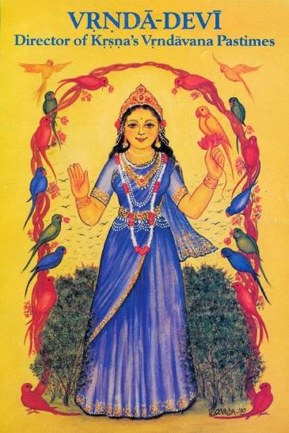

The painting gave him great joy. Each day I would hold it above his bed, as he was then bedridden, and he would chant his beautiful Sanskrit mantras to the picture form of his beloved Deity Vrinda Devi. Then, with tears in his eyes, he would begin to exclaim, “ Oh, you have made exactly Vrinda Devi, She is exactly looking like this, thank you, thank you..” Needless to say, seeing Baba’s spiritual joy was a great inspiration to all of us.

Vrinda Kunda Baba passed from this world in March of 1989, and donated his Vrinda Kund project to ISKCON. Now, every year, thousands of devotees benefit by going to Vrinda Devi’s temple for darshan. The painting of Vrinda Devi that he so loved, appeared on the cover of Back to Godhead magazine in 1993, along with the story of his departure from this world at Srila Prabhupada’s Krishna Balaram Mandir in Vrindaban.

From the perspective of transcendental art, this painting of Vrinda Devi achieved the desired result--that is, it invoked the mood of devotion. That is the purpose of transcendental art. This secret was known by some of the European masters, and it showed in their efforts to Christianize Europe.

This secret was certainly known by Srila Prabhupada. He considered our transcendental paintings to “windows to the spiritual world” as well as the “transcendental trademarks” of the Hare Krishna movement. He never wanted them altered or changed. He ordered that they never be removed from his books. He wanted his book cover art to remain unchanged, even if the book was translated into other languages. He complained if changes were made to his books, requesting that any pictures taken out should be put back in. Srila Prabhupada never wanted them altered or changed. He taught us Vedic philosophy, but he taught us transcendental artistry as well.

Art was, in his opinion, a very very important part of his preaching work, and certainly a very important part of his books. He placed great importance on the paintings he directed, as well as on the sculpture project, called the “doll making project,” headed by Bharadvaja Prabhu. Srila Prabhupada knew that Krishna consciousness would only be successful if it was a cultural conquest, with art, music, drama, and sculpture leading the way. It was never intended by him to be converted into an institutionalized religion. His own spiritual master, Srila Bhaktisiddhanta Saraswati Prabhupada, used to say, “if the Krishna consciousness becomes institutionalized, the essence will be lost.” Sadly, many of these artistic projects were lost, along with the essential direction of his movement, in the political scuffles after his departure in 1977.

Devotees like Jadurany Devi, Bharadvaja Das, Parikshit das, Pushkar das, Murlidhar das, and so many others who worked directly under the fastidious guidance of Srila Prabhupada can also provide a wealth of information about the transcendental art taught by him. It is my desire and intention to make every effort to preserve what Srila Prabhupada has given to humanity. This is truly the greatest responsibility of all of us who are Srila Prabhupada’s disciples, and who have worked directly under his guidance.

Now, in 2014, so much has already been lost. I worry what it will look like 50 or 100 years from now--or more. Srila Prabhupada’s books that were printed and spoken from by him during his lifetime have already been drastically edited, and re-edited, time and again, after his departure from this world. Paintings that he designed have been removed from them as well. And since this precedent of change has been set, it is likely they will be edited again and again in the future, after we are gone. This has happened even though most of us, Srila Prabhupada’s disciples, know that he gave us numerous warnings not to change anything in his books--not the paintings, not the covers, and certainly not the texts!

Yet, in spite of so many warnings, massive desultory editing has been done repeatedly, removing and adding whole swaths of text, as well as removing original pictures and adding “improved paintings.” The BBTI (the posthumously formed corporation that took over Srila Prabhupada’s BBT) gives elaborate explanations that seem to cloud the entire issue. At present, there are at least six versions of his Bhagavad Gita As It Is, all edited and printed several years after his demise. Yet none of them bear the customary notations showing the editors’ names, date of edit, or number of edition. This chaotic shows the BBTI as not only unprofessional, but irresponsible as well.

Nowadays, I cringe when I see paintings of muscular blue people with small heads, the modern idea of what Krishna should look like, now printed in Srila Prabhupada’s books and other ISKCON literature. Obviously, these are attempts to paint Lord Krishna as a “human being.” Srila Prabhupada’s words ring in my ears; I recall his fear that “everything will be ruined after I am gone,” and people will come to view Lord Krishna as an ordinary human being.

Of course, many of these newer paintings show excellent artistic technique, far superior to my own, yet they portray Lord Krishna with bulging muscles, snipped and turned-up Western noses, wanton expressions on His and Radharani’s faces, and poses that would never in a million years be approved of by Srila Prabhupada.

I see Krishna Books printed on the same format as Grimm’s Fairy Tales, with illustrations that would fit perfectly in a fairy tale book. They resemble the works of fantasy illustrators. The artists who are doing these works are undoubtedly highly skilled and have mastered excellent use of color and technique. But these paintings would never have been approved by Srila Prabhupada.

Decorating his Krishna Books with pictures similar to fairy tale illustrations, certainly would never meet with Srila Prabhupada’s approval. It simply gives readers the idea that Krishna Book is also no more than another fairy tale book. This message is a dangerous one; it depicts Lord Krishna as a muscular, bluish veined man, who kills demons much as any hero in any fairy tale fable.

Perhaps this article, along with example illustrations, combined with the statements of other artists who were personally trained by Srila Prabhupada, can somehow help to stave off this loss of culture and art that has so besieged our beloved Master’s ISKCON since his departure in 1977.

May Srila Prabhupada bless us with the humility and the integrity to listen to those who actually knew him, and worked closely with him. And may his kindness and mercy enable those who are firmly ensconced in their misconceptions, and “change disease,” become blessed with new realizations by the unfathomable mercy of Srila Prabhupada.

In a lecture on May 21, 1976, Honolulu, Srila Prabhupada stated “sudra means lamentation- simply changing.”

Sometimes people may be critical of the Indian Brijbasi style poster art, saying the artwork is not “realistic enough.” And perhaps it is the fear of such criticisms that enticed post-disappearance BBTI editors and publishers to make changes that Srila Prabhupada would never have approved of.

As a teasing criticism, even my husband Goursundar often called my figures “balloon faces,” and “balloon people.” But this type of transcendental form is clearly what Srila Prabhupada wanted. Transcendental form is synonymous with “milk-drinkers faces,” gently sloping arms and legs, feet sculpted to perfection, and delicate, aristocratic, even dainty, hands. There were never to be any muscles or veins showing; Srila Prabhupada was quite clear about this. Muscles and veins are for human beings, as well as for Rakshasas. But never for Krishna.

Lord Krishna appeared in the world of human beings, and at that time, many people even considered Him to be a human being. But His transcendental Form should not be confused with the mundane fleshy, clay-like forms of human beings. His form was always divine, transcendental and beyond the material nature. Srila Prabhupada wanted that our paintings of Him should look like that--transcendental.

If we depict Him looking like a blue-tinged muscular human being, he will look exactly like that: a blue-colored human. Then people will mistake Him for an ordinary man, a mere human, and the divine teachings could again be lost in time.

The act of removing Srila Prabhupada’s original paintings from Krishna Book, which he himself said were “full of bhakti” is a sure indication that there is not a correct understanding of who he is and what he came to do. He often said he “came from Krishna Loka to write some books.” And “Krishna wrote these books,” “they are actually dictated by Him.” His books, and his paintings, done by artists under his direct supervision, are “full of bhakti,” his bhakti. They cannot be changed or deleted without his direct permission.

As Srila Prabhupada’s disciples, it is our great responsibility to preserve the legacy of Srila Prabhupada. Shortly after he left this world, post-disappearance politics drove many of Srila Prabhupada’s disciples out of the ISKCON he established. Hellish havoc was wrought upon his ISKCON. Some estimate that perhaps 90% of Srila Prabhupada’s disciples stepped back from his movement shortly thereafter.

By default, those few that remained became over-night gurus, leaders, members of his GBC and even trustees in the BBT, or BBTI. Many of these leaders had not closely associated with Srila Prabhupada, and since they had little experience, they made mistakes that follow us to this day. Such inexperienced members took full control, and began to change things that Srila Prabhupada had said should never be changed--like his book texts and paintings, and his book covers.

Even the authentic procedures of Deity worship were changed, rather, reversed. Srila Prabhupada taught us to first offer everything to the Spiritual Master, and through him, we would offer to Krishna. Now, in many modern ISKCON temples, the process is exactly reversed. Devotees are taught to offer first to Lord Krishna, and then to Srila Prabhupada and the disciplic succession. This is a backwards understanding of the bhakti path Srila Prabhupada taught.

His Bhagavad Gita As It Is, the crown jewel of his writing work, as well as others of his books, have been posthumously edited, without even informing prospective readers of this. There are no names and dates to distinguish the posthumously edited books from the original ones that were read, spoken from, and approved by Srila Prabhupada during his time on earth.

The paintings of all the Acharyas in the disciplic succession, so carefully directed by Srila Prabhupada, and placed in his original Bhagavad Gita As It Is, printed in 1972, have all been removed by BBT’s (BBTI’s) inexperienced editors. In the cover picture of the greatly modified Bhagavad Gita As It Is, printed some six years after Srila Prabhupada left this world, Krishna carries a horsewhip in his hand, rather than Sri Panchajanya, His mystic conch. ln short, after 1977, Maya had her way with Srila Prabhupada’s ISKCON.

Our only hope is, like Hansel and Gretel, to leave some traces of truth along the path, in hopes that those who come later will correct things. Srila Prabhupada’s greatest fear was that “my books will be changed after my departure, and everything will be ruined.”

Observing the Judeo-Christian histories, we can see how this did indeed happen to the teachings of Jesus Christ. And although the Biblical texts still bear some resemblance to the early teachings, and thus continue to inspire people all over the world, they have lost much of their philosophical base. They cannot stand up to the scientific community; the New Science has created the New Atheism. According to edited versions, reincarnation does not exist, animals have no souls, so it is fine to kill them and eat them. The clergy that Jesus taught are no longer seen wearing simple robes and living the life of simplicity. Many wear costly embroidered silks, expensive jewelry, grand head dresses, and other such costumes--none of which Jesus taught in his time on earth. And of course, there are other philosophical and societal changes that are too numerous, or too horrible, to even mention.

Can this happen to Srila Prabhupada’s teachings? Can this happen to Lord Chaitanya’s glorious movement? Yes, it can. It has already been happening for over 30 years, moving down a road of change with no sign of turning back. Our only hope is, as Srila Prabhupada often said, “From the children of your children, pure devotees will be coming out.” Reinforcements are on the way.

We, as Srila Prabhupada’s disciples, place our hope in the future generations, and try to preserve what we can, in the hope that those who come later will do better than our generation has done. Srila Prabhupada often said, to paraphrase, “Lord Chaitanya’s movement will go on, because that is the Lord’s prediction. If you want to help, that is very good, good for you and very good for others. If not, He will send someone else to carry on His mission on this earth. That is for certain.”

“But if you don’t want to help, then at least, don’t hinder. Do not create problems, confusion and try to hinder this movement of Lord Chaitanya. That will not be good.”

Quoting Srila Bhaktisiddhanta Saraswati Thakur, the Spiritual Preceptor of our Srila Prabhupada:

“The idea of an organized church in an intelligible form, indeed, marks the close of the living spiritual movement. The great ecclesiastical establishments are the dikes and the dams to retain the current that cannot be held by any such contrivances. They, indeed, indicate a desire on the part of the masses to exploit a spiritual movement for their own purpose. They also unmistakably indicate the end of the absolute and unconventional guidance of the bonafide spiritual teacher.”

